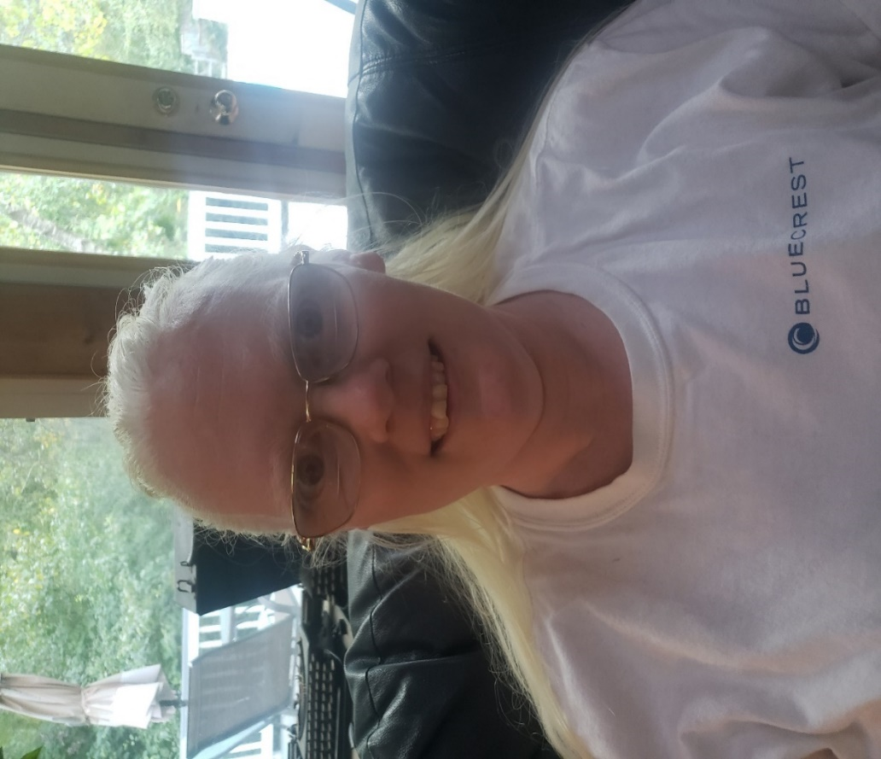

Vicki came to BESB excited to find a new job after years of being a stay at home mother. She was clear about her goals and understood that together with her Vocational Rehabilitation (VR) Counselor she would begin to search for employment in her desired field.
Through this collaboration she was interviewed and was hired at BlueCrest as a Customer Service Representative. With the provision of low vision aids Vicki was able to successfully access information required to perform her job, assisting customers and dispatching calls. When the pandemic began in early 2020, she began teleworking and needed additional services. Together with her employer and VR Counselor, Vicki worked closely to facilitate her successful transition to teleworking. Vicki has now been on the job for two years and she is very happy in her job and with BESB services.

