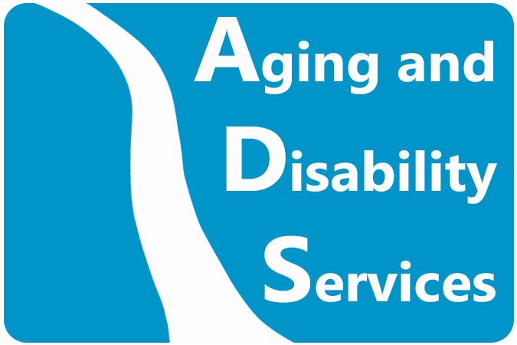

Connecticut Department of Aging and Disability Services

2022 Ethics Statement

Mission Statement

The Mission of the Connecticut Department of Aging and Disability Services (ADS) is to maximize opportunities for the independence and well-being of people with disabilities and older adults in Connecticut.
_ _ _ _ _ _ _ _ _ _ _ _ _ _

We provide a wide range of services to individuals with disabilities and older adults who need assistance in maintaining or achieving their full potential for self-direction, self-reliance and independent living.

Purpose of Ethics Policy

The ADS Ethics Policy is designed to ensure that the agency and its staff maintain the highest level of honesty and integrity in dealing with clients, vendors, fellow staff, other governmental agencies and the general public. All decisions and actions of the agency and its staff must be – in reality and in appearance - professional, impartial and free of any undue interest or influence.

All ADS employees are responsible for knowing the contents of this policy and responsible for acting in compliance with all of it provisions.

The Department of Aging and Disability Services adopts in full the current state Ethics Policy as the agency’s policy without addition or amendment. This policy applies to all employees of Aging and Disability Services. In addition, any employee so designated by the agency shall file a Statement of Financial Interests (SFI) annually with the Office of State Ethics (OSE). You will be told if you are required to file this Statement.

The published state Ethics Policy which operates as the Aging and Disability Ethics Policy was most recently updated in November of 2021. There have been no legislative acts or OSE Advisory Opinions concerning Connecticut’s ethics laws adopted since that time that need to be noted to Aging and Disability employees.

Any employee who has any questions about the agency’s Ethics Policy and any employee who observes actions or behavior that raises ethical concerns should consult with his or her immediate supervisor, the agency’s Ethics Liaison (Andrew Norton) or the Connecticut Office of State Ethics.

You may click below on a link to the November 2021 state Code of Ethics (the latest version) which will serve as the 2022 Ethics Policy for the Department of Aging and Disability Services. You may have to press Control and click on the link to get access.

2022 ADS Ethics Policy

Thank you for your attention to this important policy issuance.

Issued by Amy Porter, Commissioner, Department of Aging and Disability Services,
October 2022.

This statement and policy are issued pursuant to and in compliance with Conn. Gen. Stat. Secs. 1-83(a)(2) and 1-101rr(b).

