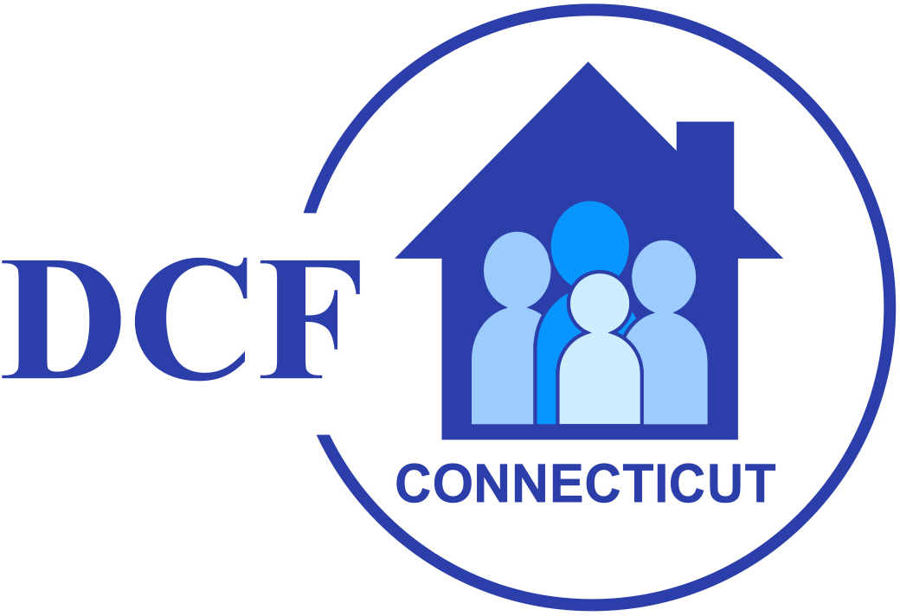
DCF-3029
(Rev. 1/13)
State of Connecticut
Department of Children and Families

Date: __/__/__

Child's Name: ___________________________________________

C/O: ___________________________________________

Address: ___________________________________________

Dear _________________________________:
[parent, legal guardian and child over 14]

This is to notify you that, pursuant to Regulations of Connecticut State Agencies §17a-11-1 through §17a-11-27 and Department of Children and Families Policies 37-1 through 37-9, the Application for Voluntary Services for [name of child] submitted on [insert date of application] is denied due to the following reason(s) [check all that apply]:

The Department has not been provided with sufficient information to establish eligibility. The following information was requested and not submitted [set forth missing information]:
____________________________________________________
________________________________________________________
________________________________________________________

The child is the subject of a pending petition in Juvenile Court alleging that he or she is
neglected, abused or uncared for.

The parent or guardian of the child has an active child protective services case with
DCF or is the subject of an ongoing investigation by DCF of an allegation of child
abuse or neglect of the child.

The child is the subject of a pending delinquency petition in Juvenile Court; has been
adjudicated delinquent and is awaiting disposition, on probation or committed to DCF; or
is currently involved with the adult criminal justice system due to arrest, conviction,
probation or parole.

Out-of-home placement of the child was made prior to the request for the Voluntary
Services program.

Out-of-home placement of the child was made in a program or facility not approved or
licensed by DCF or was arranged without the prior approval of DCF.

Out-of-home placement of the child is in or would be in a program or facility that does
not meet the treatment needs of the child as determined by DCF.

There is reasonable cause to believe that the child or the parent or guardian of the
child will not cooperate with the case plan or engage as a full participant in the
Voluntary Services program.

The child does not have an emotional, behavioral or substance abuse disorder
diagnosable under the most recent edition of "Diagnostic and Statistical Manual of
Mental Disorders" (DSM).

The child's emotional, behavioral or mental health disorder does not result in a
functional impairment of the child which substantially interferes with or limits the
child's family, school or community activities.

The child has a developmental disability and alleviation of a co-occurring emotional,
behavioral or substance abuse disorder is not the primary purpose of the request for
Voluntary Services.

The child's treatment needs can be met through services currently available to the
parent or guardian.

The child's treatment needs cannot be met through services offered or administered
by, under contract to, or otherwise available to DCF.

The child is over 18 years of age.

The child requires out-of-home care and there is no DCF-approved treatment
program or facility available.

If you disagree with the denial of your Voluntary Services application, you have the right to request a hearing. A parent or guardian of a child, or a child age 14 through 17, may request a Voluntary Services hearing. A request for a Voluntary Services hearing shall be made in writing to the Administrative Hearings Unit within 14 calendar days of receipt of this Notice of Denial of Voluntary Services.

_______________________________________________ ___________
Signature of Social Worker Supervisor or Program Manager Date

Complete the attached form (DCF-3029H) if you wish to ask for a hearing.

Mail to: Department of Children and Families
Administrative Hearings Unit
505 Hudson Street
Hartford, CT 06106

DCF-3029H NOTICE OF DENIAL OF VOLUNTARY SERVICES
(Rev. 1/13)
HEARING REQUEST

^{To Be Filled Out By Worker}
^{LINK Number:} | ^{Area Office:}
^{Social Work Supervisor:} | ^{Telephone Number:}
^{Social Worker:} | ^{Telephone Number:}
^{Date Mailed By Worker:} | ^{Issue:}  Denial of Voluntary Services

I hereby request a hearing regarding the Denial of Voluntary Services because:

____________________________________________________________________________________________________________________________________________________________________________________________________________________________________________________________________________________________________________
_________________________________________________________________________________________________________________________________________________________________________________________________________________________.

I understand that I may speak for myself or be represented by legal counsel at my expense. I also understand that I have the right to bring witnesses and any documentary evidence to support my position.

______________________________________________ ______/______/______
Signed By Person Requesting Hearing Date

Name of Person Requesting Hearing: ________________________________
(please print)

Name of Child: ______________________________________
(please print)

Address: ______________________________________________

_______________________________________________

Phone: _____________________ Email: ____________________

