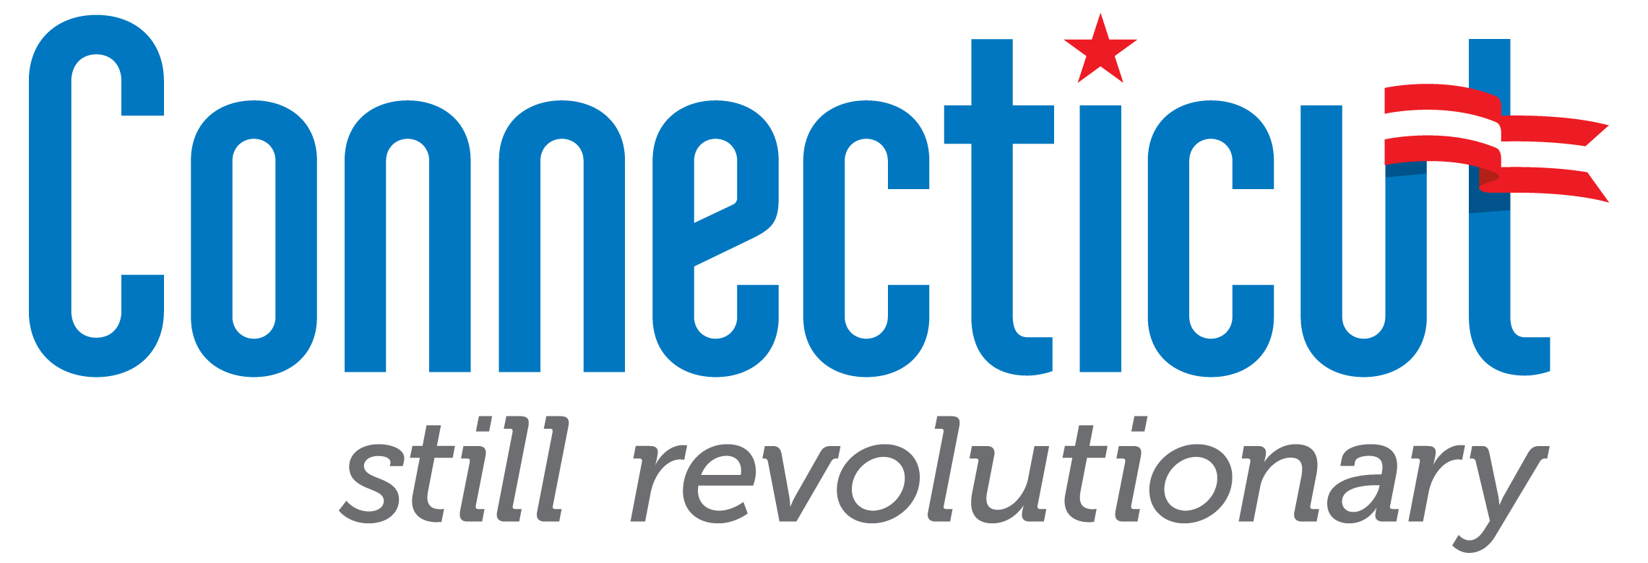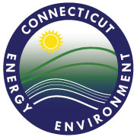
APPLICATION
CONNECTICUT BROWNFIELDS LAND BANKS PROGRAM
PUBLIC ACT 17-214

BACKGROUND:

In 2017, the Connecticut General Assembly passed a new law (Public Act 17-214, “the Act”), signed by Governor Dannel P. Malloy, authorizing the Department of Economic and Community Development (“DECD”) to certify certain specialized non-profit organizations as “Connecticut Brownfield Land Banks” (“Land Banks”).

The purpose of encouraging the formation and use of Land Banks in the State of Connecticut is, generally, to advance the remediation and redevelopment of the numerous brownfield sites throughout the State, and specifically, to give municipalities (particular smaller communities) a new set of tools to advance the redevelopment of strategic sites that might otherwise remain idle and blighted without the specialized assistance of a Land Bank.

Under the Act, Land Banks are eligible to participate in a range of Connecticut state brownfield redevelopment programs, such as grants and liability relief regimes, which are otherwise restricted to municipalities or economic development corporations.

The Act envisions the formation of multiple Land Banks that, once certified with DECD, would partner with cities and towns to redevelop brownfields.

DECD will collaborate closely with the Department of Energy and Environmental Protection (“DEEP”) to evaluate requests for certification made using this application as well as for the annual recertification progress contemplated by the Act.

“Connecticut Brownfield Land Bank” means a Connecticut nonstock corporation certified by the Commissioner of Economic and Community Development pursuant to section 2 of the Act, established for the purposes of (A) acquiring, retaining, remediating and selling brownfields in the state for the benefit of municipalities, (B) educating government officials, community leaders, economic development agencies and nonprofit organizations on best practices for redeveloping brownfields, and (C) engaging in all other activities in accordance with section 2 to 6, inclusive, of the Act.

CERTIFICATION PROCESS:
Completed applications should be submitted electronically (as PDFs) to brownfields@ct.gov. Applications will be reviewed in the order in which they are received. Applicants should expect to be invited for an in-person presentation of their business plan to DECD, DEEP and other state agencies prior to certification. DECD will provide successful applicants with a Certification Letter signed by the Commissioner.

Re-Certification Process:
The Act requires DECD to recertify Land Banks annually. Applicants who become certified should expect to provide substantial updates on all items requested in this application 60 days prior to the one-year anniversary of the date of the Certification Letter.

APPLICANT INFORMATION:
Applicant Name (Legal Entity): Telephone #:
Applicant Mailing Address: Email Address:
Contact Person: FEIN #:

Any Connecticut nonstock corporation may apply to the Commissioner of Economic and Community Development for certification as a Connecticut brownfield land bank by submitting to the commissioner the following information:
- The certificate of incorporation and bylaws of the applicant

- A list of the current officers and directors of the applicant

- A letter of support from at least two municipalities

- A proposed land banking agreement with one or more municipalities, and a detailed project description(s) of any active or proposed brownfield redevelopment projects

- A proposed business plan for the applicant, including:

  - Narrative description of the applicant’s mission, strategy and proposed activity pipeline

  - Organizational chart listing all employees, and biographies of key personnel

  - List of previously-completed projects involving key personnel

  - List of current and prospective remediation and redevelopment projects

  - Historical and projected financial statements

  - Current and expected sources of funding (including philanthropic, corporate, or public sources)

  - Current and expected sources of remediation funding for any projects listed in subsection c

CERTIFICATION BY APPLICANT:
It is hereby represented by the undersigned, that to the best of my knowledge and belief no information or data contained in the application and attachments are in any way false or incorrect and that no material information has been omitted. Your application and the contents of your application and our discussions with you are subject to public disclosure. In connection with this application, DECD may communicate with relevant municipalities, state agencies (including DEEP, the CT Department of Housing, the CT Office of Policy and Management, the CT Department of Public Health), the EPA, and the general public. It is understood by the applicant that failure to complete any element of this application may result in rejection of the application. DECD may exercise the foregoing rights at any time without notice and without liability to any applicant or any other party. Applications to this program shall be prepared at the sole expense of the applicant and shall not obligate DECD to procure any of the services described therein or herein from any applicant.

__________________________________ _____________________________________
Authorized Signature(s) Name of Person Signing (print or type)

_______________________________
Title (if applicable)

