
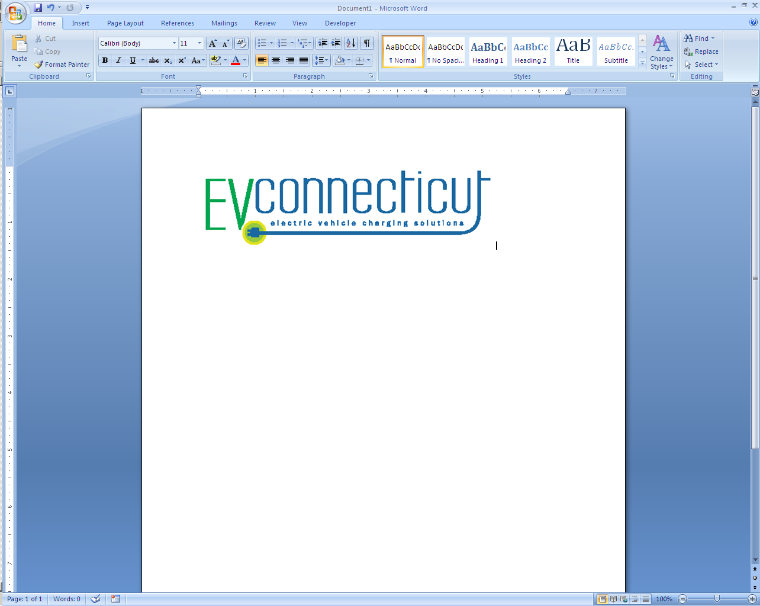
Connecticut Department of
Energy and Environmental Protection


Electric Vehicle Charging Station Resource Registration

NOTE: Complete this registration if your business sells or installs electric vehicle charging stations and you are interested in your business contact information being listed on the EVConnecticut website.

Instructions
Please complete the applicable parts of this registration and submit to evconnecticut@ct.gov or mail to Jennifer Reilly, Bureau of Air Management, CT DEEP, 79 Elm Street, 5th Floor, Hartford, CT 06106.

- Do you have the necessary licenses to conduct business in Connecticut?

Yes No (If no, Connecticut would require you to acquire the necessary licenses before you can work in Connecticut)

- Do you have experience installing electric vehicle charging equipment?

Yes No (If yes, complete the Business/Entity Information section below)

- What support can you provide the EVConnecticut program?

Business/Entity Information
Company/Entity Name:
Mailing Address:
City/Town: |  | State: |  | Zip Code:
Contact Person:
Phone Number: |  | Email:
Company Website

Please be aware that the EV Station Resource list that will be posted on the website is not an endorsement by the state of any of the companies that will be listed, but rather it is fulfilling a public service.

