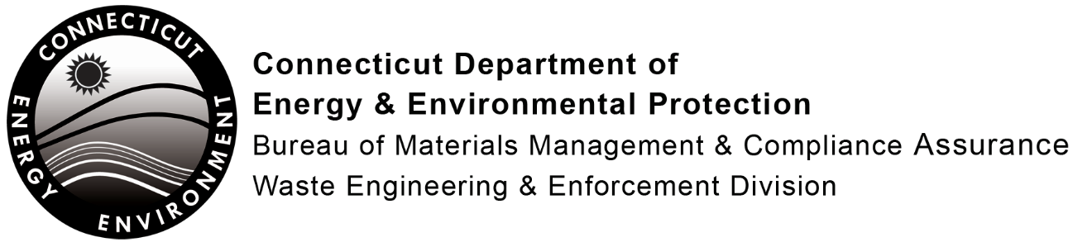
Notification of Change to DEEP-Approved Municipal E-Waste Plan for Municipal Collection and Contact Information
Complete this notification form and submit to DEEP whenever there is a change in:
- A town’s e-waste collection information, including dates, times and types of collections;
- The municipal website address for town recycling information; or
- Municipal contact information.
Information submitted using this form will be available to the public and used to update the DEEP website.
Note: Any other changes including adding or removing any e-waste drop off locations, types of municipal outreach or other program information previously approved by the DEEP must be described in a request for modification on DEEP’s Municipal E-Waste Recycling Plan form [DEP-E-WASTE-APP-001]. Such changes will need to be approved by DEEP prior to being implemented by the town.
E-Waste Drop-Off Information:
Municipality
Facility Name
(i.e. Transfer station, Recycling Center, Town Garage, etc.)
Street Number and Name
Town/City Where Collection Takes Place
Days and Times Residents Can Drop-Off Electronics
(i.e. Monday-Friday: 7:00 a.m. - 3:00 p.m.;
Saturday 8:00 a.m. - 12:00 p.m.)
Or for one-day collections:
(i.e. Sat, Mar 10, 2018: 8:00 a.m. - 1:00 p.m.)
Sat, Sept 8, 2018: 8:00 a.m. - 1:00 p.m.)
Website Address for Town Recycling Information
(Web page with most complete information for all types of recyclables in your town)
Municipal Contact Information:
Name
Title
Phone
E-mail
Your Contact Information: (For DEEP internal use only. Will not be placed on website)
Name
Title
Phone
E-mail
Submit this completed form by email to: Lena.Tan@ct.gov.

