Notice to Residents 
FREE Electronics Recycling
According to state law, Connecticut residents can recycle the following electronic items FREE of CHARGE at their local collection center:

- Computers
- Monitors
- Printers
- Televisions

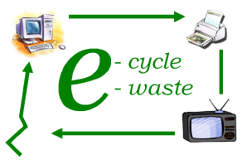

Collection Site/Hours:________________________________________

Town contact/website:________________________________________________
For more information on recycling other electronics, contact your town or www.ct.gov/dep/e-waste

Notice to Residents
FREE Electronics Recycling
According to state law, Connecticut residents can recycle the following electronic items FREE of CHARGE at their local collection center:

- Computers
- Monitors
- Printers
- Televisions

Collection Site/Hours:________________________________________

Town contact/website:________________________________________________
For more information on recycling other electronics, contact your town or www.ct.gov/dep/e-waste

