 Notice to Residents 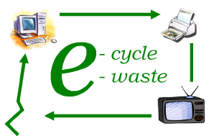
FREE Electronics Recycling
According to state law, Connecticut residents can recycle the following electronic items FREE of CHARGE at their local collection center:
Computers-Monitors-Printers-Televisions
Collection Site/Hours:______________________________________ _

Town contact/website:___________________________ _
For more information on recycling other electronics, contact your town or
www.ct.gov/dep/e-waste

Notice to Residents
FREE Electronics Recycling
According to state law, Connecticut residents can recycle the following electronic items FREE of CHARGE at their local collection center:
Computers-Monitors-Printers-Televisions
Collection Site/Hours:______________________________________ _

Town contact/website:___________________________ _
For more information on recycling other electronics, contact your town or
www.ct.gov/dep/e-waste

Notice to Residents
FREE Electronics Recycling
According to state law, Connecticut residents can recycle the following electronic items FREE of CHARGE at their local collection center:
Computers-Monitors-Printers-Televisions
Collection Site/Hours:______________________________________ _

Town contact/website:___________________________ _
For more information on recycling other electronics, contact your town or
www.ct.gov/dep/e-waste

Notice to Residents
FREE Electronics Recycling
According to state law, Connecticut residents can recycle the following electronic items FREE of CHARGE at their local collection center:
Computers-Monitors-Printers-Televisions
Collection Site/Hours:______________________________________ _

Town contact/website:___________________________ _
For more information on recycling other electronics, contact your town or
www.ct.gov/dep/e-waste

