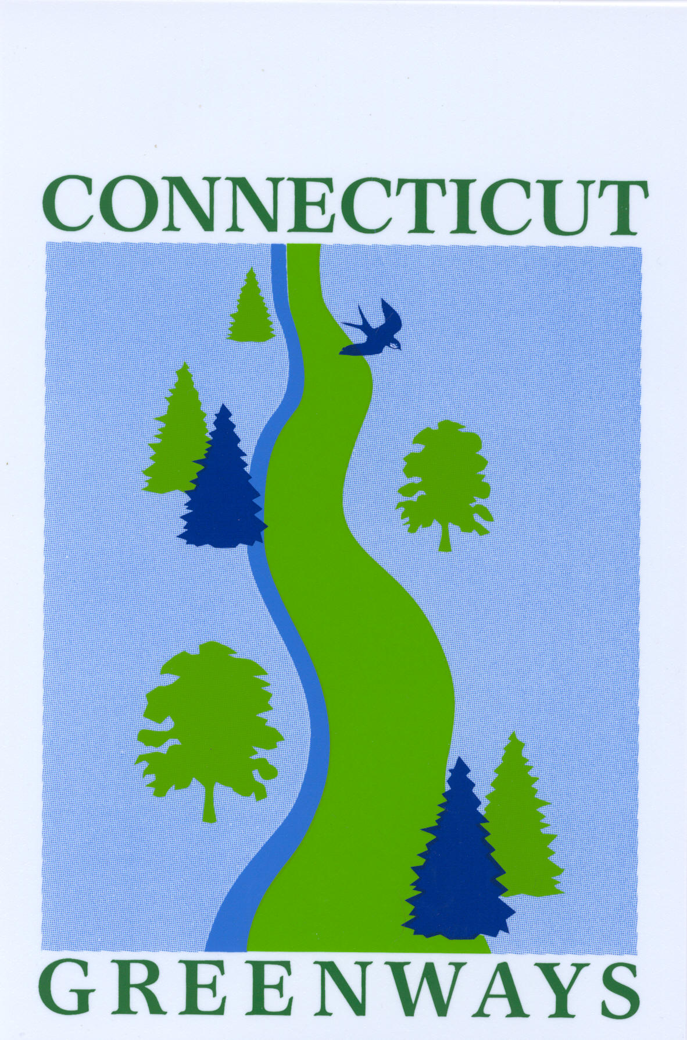

CT Greenways Council
Nomination for Official Designation of Greenway
2019

- Name of Greenway:

- Sponsoring Organization:

- Contact Name:

- Contact Email:

- Contact Address:

- Contact Phone:

- Town(s) in which greenway is/are located:

- Purpose of greenway (resource protection, recreation, etc)

- Does the corridor connect existing open space, trail segments, historical/cultural assets; provide alternative transportation opportunities; connect neighborhoods to schools, town centers, parks and recreation areas, transportation centers, or open spaces?
Yes No

- Is the segment submitted for designation a key link in an emerging greenway, either for conservation or recreation purposes?
Yes No
If yes, please provide name and location of said greenway:

- If the greenway is a municipal project, is it included in local plan of Conservation and Development?
Yes No

- Has your project been endorsed by the local government through a municipal resolution or compact?
Yes No
(If yes, please include copy – scan or digital photo)

- If the greenway is a regional project, is it included in plans of relevant Regional Planning Agency, or Council of Governments, with endorsements by the affected municipalities; or, has an inter-municipal compact been developed between towns?
Yes No (If yes, please include copies– scan or digital photo)

- If the greenway is a non-governmental project, is it sponsored by an organization with a proven record of land use protection/recreational use, or with proven resources needed for project success; are licensing, easements, or other agreements for use of state, municipal, or private land on file?
Yes No (If yes, please include copies– scan or digital photo)

- Please include a written description of the project including a map showing location, connections (existing or potential), and adjacent open space if applicable on a 1:24,000 scale USGS Topographic Map. Digital photos and maps (digital photos taken of hard copy maps are acceptable) are preferred.

Nomination forms must be returned by April 26, 2019.

Please return this form to: Laurie Giannotti, via email laurie.giannotti@ct.gov. The preferred method of submission is via email. Alternatively, you may mail digital reports on a CD or other electronic storage devices as appropriate. Digital photos and maps (digital photos taken of hard copy maps are acceptable) are also preferred.

Contact information:
Laurie Giannotti
Trails and Greenways Coordinator
Department of Energy & Environmental Protection
79 Elm Street
Hartford, CT 06106

Phone (860) 424-3578

The Connecticut Department of Energy and Environmental Protection is an Affirmative Action/Equal Opportunity Employer that is committed to complying with the requirements of the Americans with Disabilities Act. Please contact us at (860) 418-5910 or deep.accommodations@ct.gov if you: have a disability and need a communication aid or service; have limited proficiency in English and may need information in another language; or if you wish to file an ADA or Title VI discrimination complaint.

