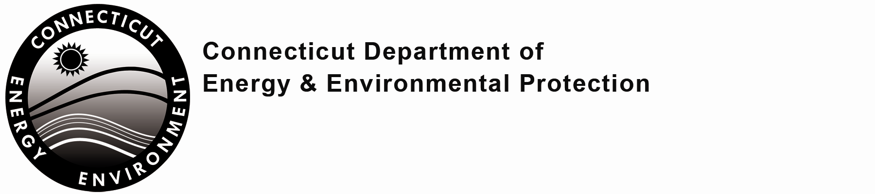

Pre-Application Questionnaire

In order to ensure we have an effective pre-application meeting, please review every question and respond where applicable. Your answers will help us identify which program staff should attend the meeting.

Send completed form to the Office of Planning and Program Development (OPPD): by email to: DEEP.OPPD@ct.gov, or by regular mail to: OPPD, Department of Energy and Environmental Protection, 79 Elm Street, Hartford, CT 06106-5127.
For questions, contact the OPPD at 860-424-3003.

Part I: Contact Information
1. Proposed Applicant Name:
Applicant Contact Person:
Phone: Email:
2. Pre-Application Meeting Contact Person (if not the Applicant Contact):
Phone: Email:
Affiliation:
Part II: Project Information
1. Project Address (if known):
City/Town:
2. Project Type: (check every category which applies)
Existing Business requiring a new license or modification of an existing license
New Business Residential Mixed Use
New Construction Commercial/Industrial Municipal
Other (please specify):
3. Project Description:

Part II: Project Information (continued)
4. Description of the site as it currently exists and what changes would occur as a result of the project.

Part III: Project Activities
Check each activity that may be applicable to your project (check all that apply):
Environmental remediation or decontamination prior to future use of the site
Site located in a coastal area
Site located in an aquifer protection area
Site located in a CT DEEP Natural Diversity Database state listed species habitat
Site located in an Environmental Justice Community
Property subject to the Property Transfer Act
Disturbance of land area
If so, extent of area disturbed (in acres):
Construction of a pond or surface water impoundment, including those used for sedimentation, stormwater retention/detention
If so, will it be (check one): temporary or permanent
Constructing, altering, rebuilding, or substantially repairing any dam, dike or similar structure
Alteration (e.g., excavating/dredging) of any tidal or inland wetlands, watercourses, flood plains or floodways
If so, what is the extent of the area to be altered (in acres)?
If so, will there be fill, dredging and/or excavation?
Installing a structure within a tidal or inland wetland or watercourse?
Individual piece of equipment or a process which has the potential to emit 15 tons or more per year of any individual air pollutant or meet any other applicability requirement of RCSA Section 22a-174-3a(a)
If so, provide the total proposed annual emissions for the project (tpy):
PM₁₀/PM_{2.5}: VOC:
SOx: CO:
NOx: HAPs:

Management of wastes either generated on-site or off-site
If so, what types of wastes will be managed? (Check all that apply)
Municipal Solid Waste Hazardous Wastes (RCRA)
Recyclable Wastes Connecticut Regulated/Special Wastes
Biomedical Wastes Radioactive Wastes
Other; specify
Storage of any liquids or gaseous fuels or chemicals at the site
If so, please describe proposed storage (e.g., above ground, underground, tank size, vapor pressure, etc.):
Use or storage of pesticides
Manufacturing, possession, use, or disposal of any radioactive materials (e.g., x-ray and materials testing equipment, etc.)

Part III: Project Activities (continued)
Discharges of wastewater (other than domestic sewage) including but not limited to: contact and non-contact cooling water; blowdown from heating and cooling equipment; process wastewaters; rinsewaters; floor drainage; or other wastewaters
If so, please identify below, listing projected daily volume and proposed discharge location (i.e., surface water, sanitary sewer, groundwater).
 | Wastewater Type | Volume (gal/day) | Discharge Location
Utilization of a sanitary sewage disposal system
If so, indicate method and volume (gallons per day):
Method Volume (gpd)
Subsurface sewage treatment and disposal system
Publicly owned treatment works
Privately owned treatment works
Other (please specify):

Withdrawal of groundwater from one or more wells joined in one system whose combined maximum withdrawal exceeds 50,000 gallons of water during any twenty-four hour period
If so, provide: the location of well(s) (lat/long):
quantity of water diverted (million gallons per day):
Withdrawal of surface waters in excess of 50,000 gallons during any twenty-four hour period
If so, provide: name of withdrawal source:
location of withdrawal source (lat/long):
quantity of water diverted (million gallons per day):
Transfer of more than 50,000 gallons of water in any twenty-four hour period from one water supply distribution system or service area to another such distribution system or service area, or installation of capacity to transfer such water
If so, provide: name of distribution system(s)/service area(s):
quantity of water transferred (million gallons per day):

Utilization of any public funds
If so, check type: Federal State
If there is a state agency other than DEEP involved in the project and/or managing federal funds related to this project, please list the agency, and a project contact at that agency.

Note: If applicable, you may attach a site plan along with this completed questionnaire or bring a site plan to the pre-application meeting. Please refer to the Pre-Application Guidance to better prepare for the pre-application meeting.

