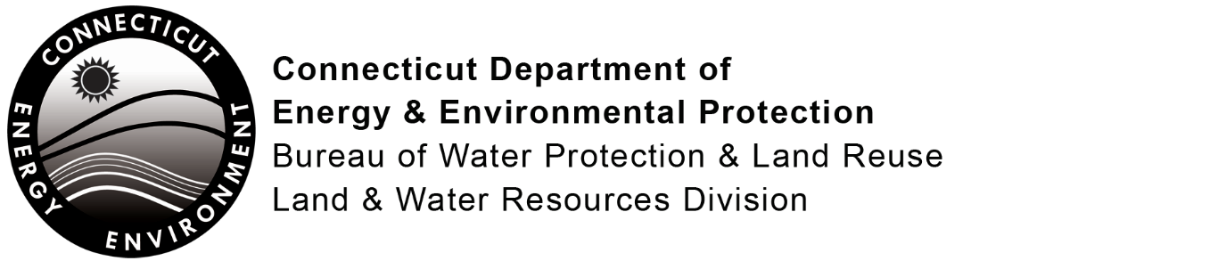

LWRD License Application
Pre-Submission Consultation Form

State of CT, Department of Agriculture, Bureau of Aquaculture
A pre-submission consultation with Aquaculture is required for some of the LWRD license applications. Please refer to the application form for specific projects and locations which require consultation.
To the applicant- Prior to the submission of your license application to the Connecticut Department of Energy and Environmental Protection (DEEP) Land & Water Resources Division (LWRD), please complete Part I and submit this form to the Department of Agriculture, Bureau of Aquaculture (“DOA/BOA”) by: hardcopy, P.O. Box 97, Milford, CT, 06460; facsimile, 203-783-9976; or e-mail, david.carey@ct.gov. Include a location map of your site and project plans. Once the DOA/BOA returns the completed form to you, please submit it along with your license application to DEEP.
Part I: To be completed by APPLICANT
- Applicant/Registrant Information
Name:
Mailing Address:
City/Town: State: Zip Code:
Business Phone: Ext.:
Contact Person: Title:
Business Phone: Ext.:
E-mail:
2. Engineer/Surveyor/Agent Information (list as applicable)
Name: Title:
Mailing Address:
City/Town: State: Zip Code:
Business Phone: Ext.:
Contact Person: Title:
Business Phone: Ext.:
E-mail:
Service Provided:
3. Site Location:
Name of Site :
Street Address:
City/Town: State: Zip Code:
Tax Assessor's Reference: Map Block Lot
Name of Waterbody:
4. Confirm location map and site plans are attached.
Date of plans:

Part I: To be completed by APPLICANT (continued)
5. Provide or attach a brief, but thorough description of the project.

Part II: To be completed by DOA/BOA
This consultation form is required to be submitted as part of an application for a Structures, Dredging & Fill license (Connecticut General Statutes (CGS) Section 22a-361) and/or Tidal Wetlands license (CGS Section 22a-32) and some of the General Permits to DEEP LWRD. The application has not yet been submitted to DEEP. Please review the enclosed materials and determine whether the project will significantly impact shellfish beds. You may also provide comments or recommendations regarding the proposal. Should you have any questions regarding this process, please call DEEP LWRD at 860-424-3019. Please return the completed form to the applicant.

CGS Section 22a-361(b) requires that the Commissioner of DEEP shall hold a public hearing on license applications submitted pursuant to CGS section 22a-361 provided that a petition requesting such hearing signed by 25 or more persons is received and if the project will significantly impact any shellfish area, as determined by the DOA/BOA.

DOA/BOA DETERMINATION:
Project located on (check one): natural bed state bed local bed none
other, please specify:

If project is located upon a franchised or leased shellfish bed, please provide the owner or lessee’s contact information below.

Check one of the following:
I have determined that the work described in Part I of this form and attachments WILL NOT significantly impact any shellfish area.
I have determined that the work described in Part I of this form and attachments WILL significantly impact any shellfish area and that a public hearing must be held if the DEEP issues a public notice for the project as currently designed and a qualified petition is received.
COMMENTS/RECOMMENDATIONS (or check here if attached: ):

Signature of Commission Representative |  | Date
Print Name of Commission Representative |  | Title

