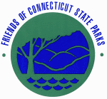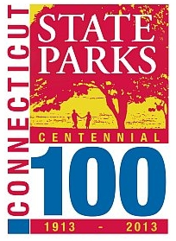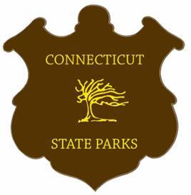

DONATE BY MAIL:

State Park Centennial Events are funded through private donations rather than taxpayer funds. All donations are greatly appreciated and will be recognized. To make your gift, please print and fill out this form and mail it (with the check enclosed) to:

Friends of Connecticut State Parks, Inc.
16 Meriden Road
Rockfall, CT 06481-2961

Make checks payable to: Friends of Connecticut State Parks, Inc. (with “Centennial” in the memo line)

Amount: $______________

Name: ______________________________________

Address: _____________________________________

City: __________________ State: _________ ZIP: __________

Country: _________ Email: _____________________________

Dedication Options (optional)

Would you like this donation to be listed as anonymous? (please circle) YES NO

In Memory Of: ____________________ In Honor Of: ____________________

Other reason for donating: ______________________________

If you have questions regarding donations or sponsorship opportunities, please contact:

Pamela Adams, Centennial Chair: pamela_aey_adams@sbcglobal.net

OR

Tom Tyler, Director of Connecticut DEEP State Parks: tom.tyler@ct.gov

THANK YOU FOR YOUR SUPPORT!!

