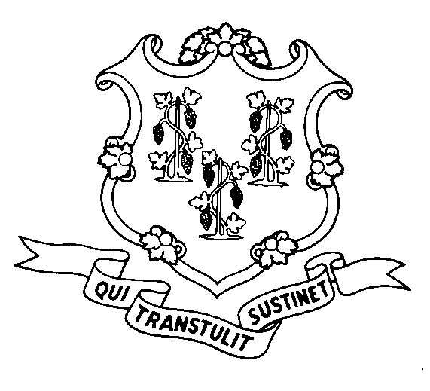

W-1130
(Rev. 7/16)
STATE OF CONNECTICUT
DEPARTMENT OF SOCIAL SERVICES

ACQUIRED BRAIN INJURY (ABI) WAIVER REQUEST FORM

1. Personal Data

Name Social Security #

Address
No. Street Apt. No.

City State Zip Code

Telephone ( ) Age Date of Birth ⁄ ⁄
(month) (day) (year)
Single Married Widowed Divorced

Contact person if other than yourself:

Name Telephone ( )

Address
No. Street Apt. No.

City State Zip Code

Relationship Conservator of Person Conservator of Estate
(check all that apply) Other (specify)

2. ABI Information

Do you have an acquired brain injury? Yes No

If Yes, please indicate date of injury ⁄ ⁄ and diagnosis

3. Freedom of Choice - Please read the following and check the box that indicates your choice.

If possible, I would prefer to live in the community rather than a nursing home or other institutional setting.
I would prefer to live in a nursing home or other similar setting.

4. Medicaid (Title 19) and Medicare Information

Please check the blocks that apply to you:
I am receiving Medicare benefits (enter claim number)
I am receiving Medicaid/Title 19 benefits (enter case number)
I have a Medicaid "Spenddown" (enter case number, if known)

I have applied for Medicaid benefits but have not received a decision
I have not applied for Medicaid benefits

5. Financial Data

My total monthly income (for example, Social Security, SSI, disability benefits, pension benefits, Workers Compensation, wages, contributions, income from interest or dividends, etc.) is:

Amount | Source
My total assets (for example, cash, bank accounts, IRAs, life insurance, annuities, stocks, bonds, motor vehicles, property, etc.)

Amount | Source

Signature of Applicant Date

Signature of Conservator or Other Representative Date

Typed or Printed Name of Conservator or Other Representative Date

Return This Form To:

Department of Social Services
55 Farmington Avenue
Hartford, CT 06105-3730

Attention: Community Options Unit
9th Floor

Persons who are deaf or hard of hearing and have a TTD/TTY device can contact DSS at 1-800-842-4524. Persons who are blind or visually impaired, can contact DSS at 1-860-424-5040.

