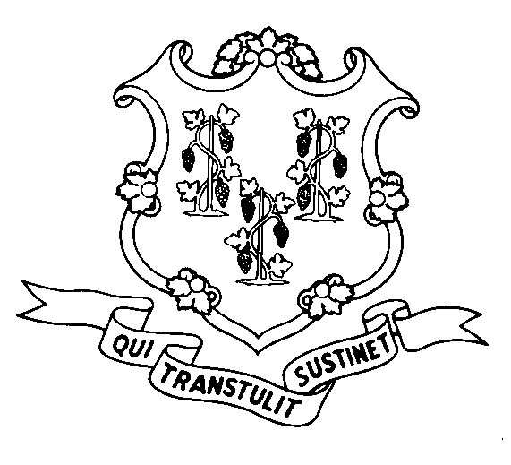
STATE OF CONNECTICUT

DEPARTMENT OF SOCIAL SERVICES

UNIFORM POLICY MANUAL

_________________________________ July 1, 2002
Rita M. Pacheco, Deputy Commissioner Effective Date

POLICY TRANSMITTAL NO.: UP-02-04

SUBJECT: Personal Needs Allowance Increase for Residents of Long Term Care Facilities

This transmits procedures to increase the personal needs allowance of Medicaid recipients who reside in long term care facilities from $54 to $55 per month pursuant to Public Act 98-239. Public Act 98-239 states that the personal needs allowance will increase every July 1st, beginning July 1, 1999, by the cost of living adjustment afforded to Social Security recipients. The Social Security cost of living adjustment was 2.6% for 2002. The cumulative Social Security increases have been rounded to the nearest dollar.

The increase in the personal needs allowance also affects long term care facility residents who receive Improved Pensions from the Veterans’ Administration. These pensions are limited to $90 per month and are paid to institutionalized veterans (or their surviving spouses) without dependents. Effective July 1, 2002, these recipients will be afforded the $55 personal needs allowance in addition to the amount of their Improved Pensions for a total of $145 per month.

Nursing facility residents receiving reduced SSI benefits of $30 are entitled to receive $25 per month in State Supplement benefits effective July 1st. Recurring State Supplement special benefits will be increased by $1 by an EMS mass modification.

INSTRUCTIONS FOR UPDATING THE UPM:

Remove and Recycle Insert

P-4520.05 P-4520.05
P-5045.25 P-5045.25
P-5045.25 page 2 P-5045.25 page 2
P-5045.30 P-5045.30

DISPOSITION: This Policy Transmittal may be retained for reference.

DISTRIBUTION: UPM list

RESPONSIBLE UNIT: Adult Support - Telephone (860) 424-5250

Date Issued:

MCS
An Equal Opportunity / Affirmative Action Employer
Printed on Recycled or Recovered Paper

