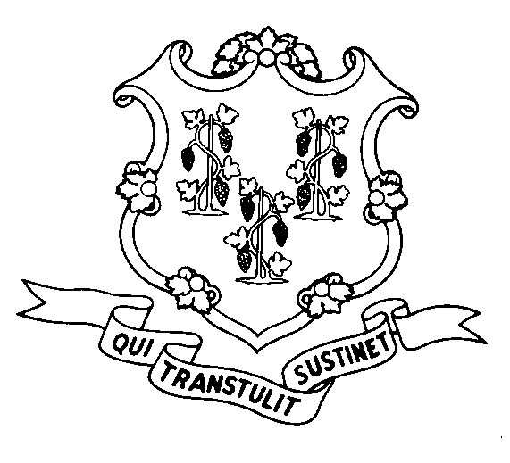
STATE OF CONNECTICUT

DEPARTMENT OF SOCIAL SERVICES

UNIFORM POLICY MANUAL

________________________________ November 1, 2002
Rita M. Pacheco, Deputy Commissioner Effective Date

POLICY TRANSMITTAL NO.: UP-02-22

SUBJECT: Home Delivered Meals

This transmittal revises the maximum daily rate (flat fee) for home delivered meals (Meals on Wheels) under the State Supplement program. The new rate is $4.43 per day for single meal delivery and $8.09 per day for double meal delivery.

INSTRUCTIONS FOR UPDATING THE UPM:

Remove and Recycle Insert

P-4525.10 P-4525.10

DISPOSITION: This policy transmittal may be recycled once the UPM has been updated.

DISTRIBUTION: UPM list

RESPONSIBLE UNIT: Adult Support Unit – Telephone (860) 424-5250

Date Issued:

MCS
An Equal Opportunity / Affirmative Action Employer
Printed on Recycled or Recovered Paper

