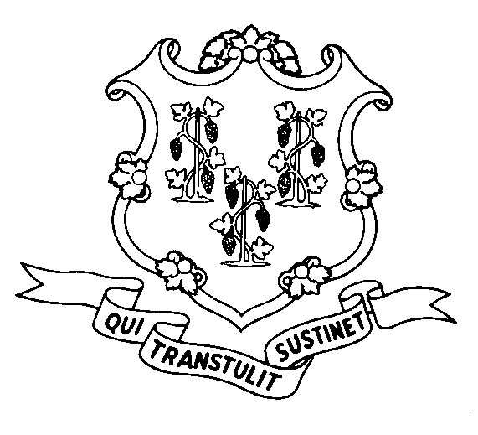
STATE OF CONNECTICUT

DEPARTMENT OF SOCIAL SERVICES

UNIFORM POLICY MANUAL

_________________________________ July 1, 2000
Rita M. Pacheco, Deputy Commissioner Effective Date

POLICY TRANSMITTAL NO.: UP-03-02

SUBJECT: Technical Revisions to SAGA Medical Non-Citizen Requirements Policy

Attached is a revised UPM page reflecting language corrections required by the Legislative Regulation Review Committee.

There are no changes in the substance of the regulation.

INSTRUCTIONS FOR UPDATING THE UPM:

Remove and Recycle Insert

8080.30/8080.30 page 2 8080.30/8080.30 page 2

DISPOSITION: This Policy Transmittal may be retained for reference.

DISTRIBUTION: UPM list

RESPONSIBLE UNIT: Adult Support - Telephone (860) 424-5250

Date Issued:

MCS
An Equal Opportunity / Affirmative Action Employer
Printed on Recycled or Recovered Paper

