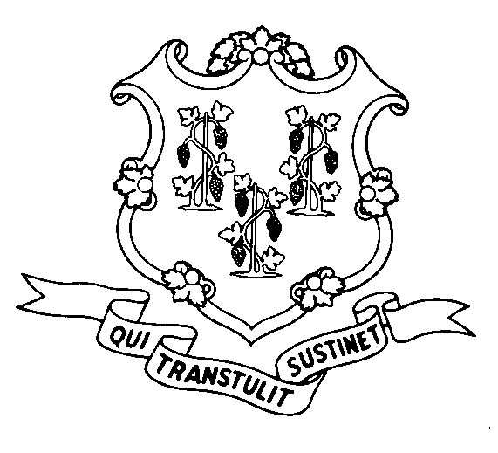
STATE OF CONNECTICUT

DEPARTMENT OF SOCIAL SERVICES

UNIFORM POLICY MANUAL

________________________________ April 1, 2003
An Equal Opportunity / Affirmative Action Employer
Printed on Recycled or Recovered Paper
Rita M. Pacheco, Deputy Commissioner Effective Date

POLICY TRANSMITTAL NO.: UP-03-04

SUBJECT: Revised Federal Poverty Level Tables

This transmittal provides revised procedural pages to reflect recently published 2003 Federal Poverty Levels. The new figures include income limits for the CADAP, CIAPAP, QDWI, QMB, SLMB, ALMB Poverty Level Coverage Groups, Husky A for families, Husky A for children, and Husky A for pregnant women. The figures are also used to determine presumptive eligibility for pregnant women, applied income under the CHC, DMR, PCA, and ABI waivers, the gross earnings test for Jobs First clients.

Please note that the new minimum MMNA (Minimum Monthly Needs Allowance) amount changes on July 1 of each year.

Included with this transmittal, for use as a desk guide, is a table with the different percentages of the Federal Poverty Level.

INSTRUCTIONS FOR UPDATING THE UPM:

Remove and Recycle Insert

P-1520.05 P-1520.05
P-4530.20 P-4530.20
P-4530.25 P-4530.25
P-4530.26 P-4530.26
P-4530.27 P-4530.27
P-4530.28
P-4530.29 P-4530.29
P-8035.05 P-8035.05
P-8036.10 P-8036.10

DISPOSITION: This policy transmittal may be recycled once the UPM has been updated.

DISTRIBUTION: UPM list

RESPONSIBLE UNIT: Adult Support Unit – Telephone (860) 424-5250

Date Issued: 03-31-03

WNG

