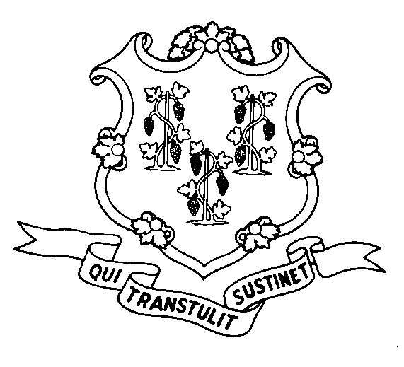
STATE OF CONNECTICUT
DEPARTMENT OF SOCIAL SERVICES
UNIFORM POLICY MANUAL

______________________________________ November 1, 2001
Claudette J. Beaulieu, Deputy Commissioner Effective Date

POLICY TRANSMITTAL NO.: UP-04-15

SUBJECT: Technical Corrections to the Uniform Policy Manual

The Legislative Regulations Review Committee (LRRC) has approved the department’s regulations on changes to Food Stamp policy due to the expiration of the Food Stamp waivers for Welfare Reform with the attached technical corrections to UPM 4030.66.

The LRRC required that we change "IRA's" to "IRAs" for proper punctuation and to maintain consistency with other references in the section.

INSTRUCTIONS FOR UPDATING THE UPM

Remove and Recycle Insert

4030.65 page 4/4030.66 4030.65 page 4/4030.66

DISPOSITION: This Policy Transmittal may be recycled once the UPM has been updated.

DISTRIBUTION: UPM list

RESPONSIBLE UNIT: Family Support - 860 424-5383

WMT Date Issued:
25 SIGOURNEY STREET - HARTFORD, CONNECTICUT 06106-5033
An Equal Opportunity / Affirmative Action Employer
Printed on Recycled or Recovered Paper

