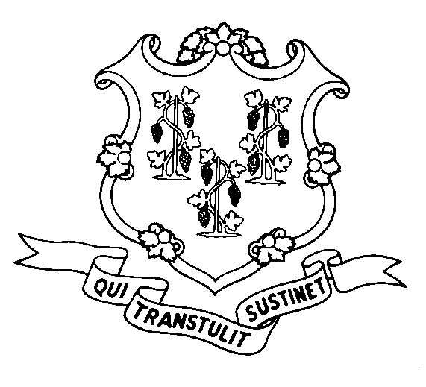
STATE OF CONNECTICUT
DEPARTMENT OF SOCIAL SERVICES
UNIFORM POLICY MANUAL

______________________________________ September 1, 2003
Claudette J. Beaulieu, Deputy Commissioner Effective Date

POLICY TRANSMITTAL NO.: UP-04-17

SUBJECT: Technical Corrections to the Uniform Policy Manual

The Legislative Regulations Review Committee (LRRC) has approved the department’s regulations on changes to Food Stamp policy related to the penalty period for a transfer of asset, in the Food Stamp program, with the attached technical corrections to UPM 3025.50.

The LRRC required that the page contain a cross reference to 1500.01 - Adequate Notice, for clarity with respect to the referenced 'notice of adverse action'.

INSTRUCTIONS FOR UPDATING THE UPM

Remove and Recycle Insert

3025.50/******* 3025.50/*******

DISPOSITION: This Policy Transmittal may be recycled once the UPM has been updated.

DISTRIBUTION: UPM list

RESPONSIBLE UNIT: Adult Services Division - 860 424-5383

WMT Date Issued:
25 SIGOURNEY STREET - HARTFORD, CONNECTICUT 06106-5033
An Equal Opportunity / Affirmative Action Employer
Printed on Recycled or Recovered Paper

