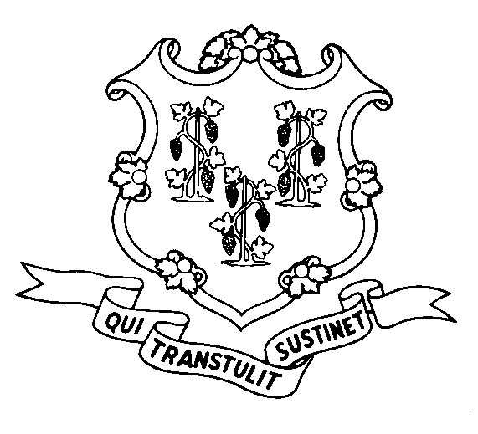
STATE OF CONNECTICUT
DEPARTMENT OF SOCIAL SERVICES
UNIFORM POLICY MANUAL

______________________________________ October 1, 2004
Claudette J. Beaulieu, Deputy Commissioner Effective Date

POLICY TRANSMITTAL NO.: UP-04-22

SUBJECT: Technical Corrections to the Uniform Policy Manual

The Legislative Regulations Review Committee (LRRC) has approved the department’s regulations on changes to treatment of Ricky Ray Hemophilia Act funds, in the Food Stamp program, with the attached technical corrections to UPM 5015.15.

The LRRC required section 5015.15(B)(4)(b) be changed from "student sin" to "students in" and 5015.15(B)(6)(b) from "theFood" to "the Food" for proper form.

INSTRUCTIONS FOR UPDATING THE UPM

Remove and Recycle Insert

5015.15 page 7/5015.15 page 8 5015.15 page 7/5015.15 page 8
5015.15 page 9/5015.15 page 10 5015.15 page 9/5015.15 page 10

DISPOSITION: This Policy Transmittal may be recycled once the UPM has been updated.

DISTRIBUTION: UPM list

RESPONSIBLE UNIT: Adult Services Division - 860 424-5383

WMT Date Issued:
25 SIGOURNEY STREET - HARTFORD, CONNECTICUT 06106-5033
An Equal Opportunity / Affirmative Action Employer
Printed on Recycled or Recovered Paper

