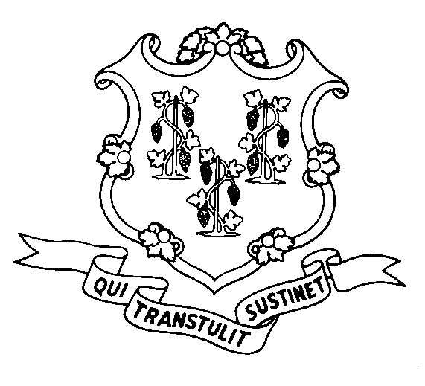
STATE OF CONNECTICUT

DEPARTMENT OF SOCIAL SERVICES

UNIFORM POLICY MANUAL

___________________________________ January 1, 2005
Claudette J. Beaulieu, Deputy Commissioner Effective Date

POLICY TRANSMITTAL NO.: UP-04-28

SUBJECT: Updated Fair Hearing Procedures

This transmits revised UPM procedural pages concerning Fair Hearings. The updates include replacing references to the Fair Hearings Unit with the Office of Legal Counsel, Regulations and Administrative Hearings (OLCRAH), revised address, telephone and fax numbers for OLCRAH and more detailed hearings procedures.

INSTRUCTIONS FOR UPDATING THE UPM:

Remove and Recycle Insert

P-1570.10 P-1570.10
P-1570.10 pg.2 P-1570.10 pg.2
***** P-1570.10 pg.3
P-1570.12 P-1570.12
P-1570.15 P-1570.15
P-1570.20 P-1570.20
P-8080.15 pg. 11 P-8080.15 pg. 11
DISPOSITION: This policy transmittal may be recycled once the UPM has been updated.

DISTRIBUTION: UPM list

RESPONSIBLE UNIT: Adult Support Unit – Telephone (860) 424-5250

Date Issued:

MCS
An Equal Opportunity / Affirmative Action Employer
Printed on Recycled or Recovered Paper

