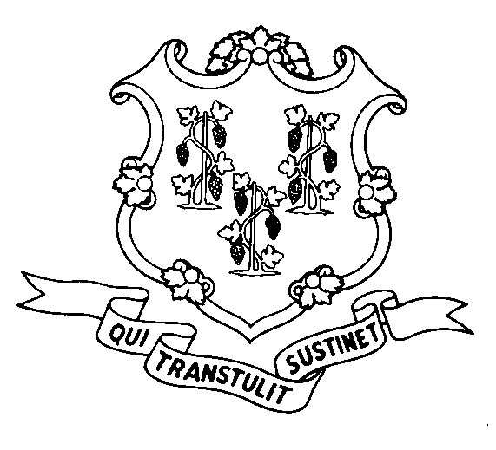
STATE OF CONNECTICUT

DEPARTMENT OF SOCIAL SERVICES

UNIFORM POLICY MANUAL

________________________________________ February 1, 2006
Claudette J. Beaulieu, Deputy Commissioner Effective Date

POLICY TRANSMITTAL NO.: UP-06-01

SUBJECT: Measuring the thirty-six month period for clients who are subject to the Food Stamp time limit

This transmittal issues new policy on how to measure the thirty-six month period when determining if an Able Bodied Adult Without Dependents has met the Food Stamp time limit.

An ABAWD is not eligible to participate in the Food Stamp Program as a member of any household if the individual received food stamps for more than three full countable months during a 36-month period, unless exempt from Employment & Training registration requirements, works or participates in an approved employment & training activity for 80 hours per month, or is exempt from the food stamp work requirements.

Currently, the 36-month period is a rolling period and staff must look back 36 months from the date of the application and keep looking back each ensuing month.

Under the new policy, the 36-month period will be fixed and have a definite start and end date. The start dates runs continuously for 36 months and the same 36-month period will be used for all ABAWDs.

INSTRUCTIONS FOR UPDATING THE UPM:

Remove and Recycle Insert

3512.10/3512.15 3512.10/3512.15
3512.15 Page 2 3512.15 Page 2
XXXXX P-3512.15

DISPOSITION: This policy transmittal may be recycled once the UPM has been updated.

DISTRIBUTION: UPM list

RESPONSIBLE UNIT: Adult Support Unit – Telephone (860) 424-5383.

Date Issued:

WT
An Equal Opportunity / Affirmative Action Employer
Printed on Recycled or Recovered Paper

