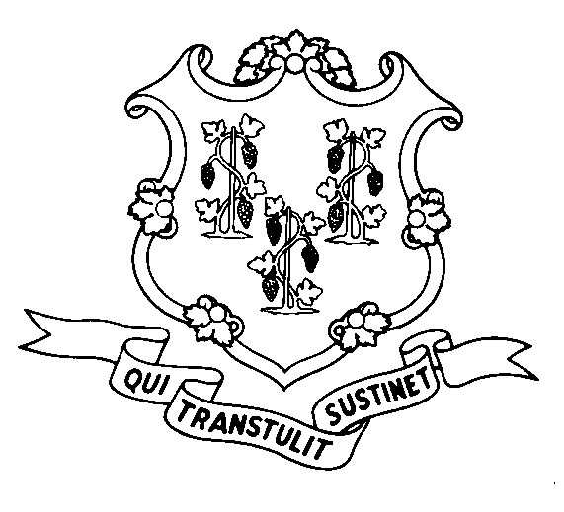
STATE OF CONNECTICUT

DEPARTMENT OF SOCIAL SERVICES

UNIFORM POLICY MANUAL

April 1, 2006
Claudette J. Beaulieu, Deputy Commissioner Effective Date

POLICY TRANSMITTAL NO.: UP-06-11

SUBJECT: Treatment of Burial Funds in the Food Stamp Program

Currently the Uniform Policy Manual states that, for Food Stamp purposes, a burial fund is a counted asset unless it cannot be liquidated during the certification period, and is therefore inaccessible.

Federal regulations have been changed to exclude as an asset, one burial fund per Food Stamp household member, up to a maximum value of $1,500. The amount that exceeds $1,500 is counted towards the Food Stamp asset limit.

Please note that irrevocable burial funds continue to be excluded assets.

INSTRUCTIONS FOR UPDATING THE UPM:

Remove and Recycle Insert

4030.10/4030.15 4030.10/4030.15
P-4030.15 P-4030.15

DISPOSITION: This Policy Transmittal should be retained for reference.

DISTRIBUTION: UPM list

RESPONSIBLE UNIT: Adult Services/Food Stamps (860) 424-5383

WMT Date Issued: 4/5/06

An Equal Opportunity / Affirmative Action Employer
Printed on Recycled or Recovered Paper

