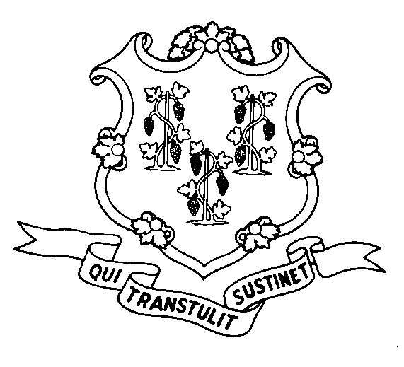
STATE OF CONNECTICUT
DEPARTMENT OF SOCIAL SERVICES
UNIFORM POLICY MANUAL

______________________________________ January 1, 2006
Claudette J. Beaulieu, Deputy Commissioner Effective Date

POLICY TRANSMITTAL NO.: UP-06-15

SUBJECT: Increase in the Special Categorically Needy Income Limit.

This transmittal issues the new special Categorically Needy Income Limit (CNIL) for institutionalized applicants/recipients. The special CNIL will be increased to $1,809.00 per month for an assistance unit of one and $3,618.00 per month for an assistance unit of two. The special CNIL for Connecticut Home Care (CHC) applicants/recipients will be increased to $1,809.00.

INSTRUCTIONS FOR UPDATING THE UPM:

Remove and Recycle Insert

P-2540.60 P-2540.60
P-2540.88 P-2540.88
P-4530.10 P-4530.10
P-5520.10 P-5520.10
P-5520.15 page 2 P-5520.15 page 2

DISPOSITION: This Policy Transmittal may be recycled once the UPM has been updated.

DISTRIBUTION: UPM list

RESPONSIBLE UNIT: Adult Support, (860) 424-5250
Date Issued:

SM

25 SIGOURNEY STREET - HARTFORD, CONNECTICUT 06106-5033
An Equal Opportunity / Affirmative Action Employer
Printed on Recycled or Recovered Paper

