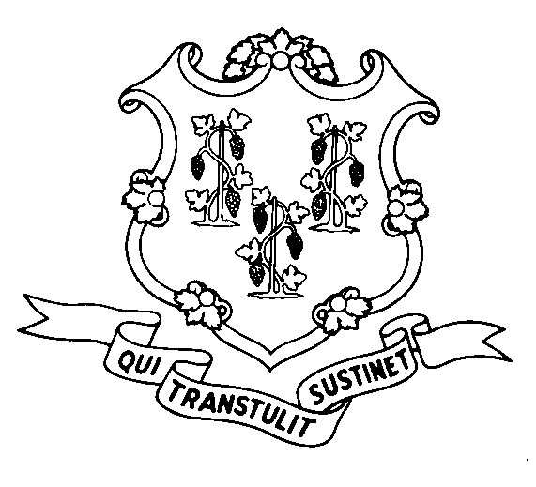
STATE OF CONNECTICUT

DEPARTMENT OF SOCIAL SERVICES

UNIFORM POLICY MANUAL

June 1, 2006
Claudette J. Beaulieu, Deputy Commissioner Effective Date

POLICY TRANSMITTAL NO.: UP-06-17

SUBJECT: Update of Table of Contents

This transmittal updates the Table of Contents.

In addition, obsolete Transfer of Assets policy is being removed.

INSTRUCTIONS FOR UPDATING THE UPM:

Remove and Recycle Insert

0300 0300
0300.10 0300.10
0300.15 0300.15
0300.25 0300.25
0300.30 0300.30
0300.35 0300.35
0300.40 0300.40
0300.45 0300.45
0300.50 0300.50
0300.55 0300.55
0300.60 0300.60
0300.65 0300.65
0300.80 0300.80
0300.85 0300.85
0300.90 0300.90
0300.95 0300.95

3026 (Entire Section) ******

DISPOSITION: This Policy Transmittal should be retained for reference.

DISTRIBUTION: UPM list

RESPONSIBLE UNIT: Assistance Programs (860) 424-5540

Date Issued: 6/8/06

An Equal Opportunity / Affirmative Action Employer
Printed on Recycled or Recovered Paper

