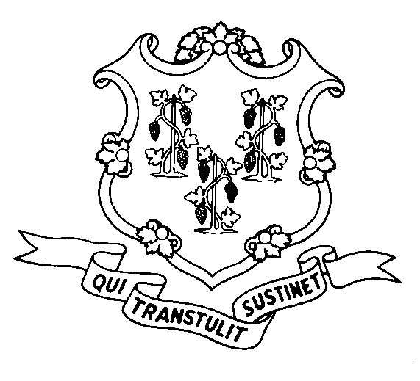
STATE OF CONNECTICUT
DEPARTMENT OF SOCIAL SERVICES
UNIFORM POLICY MANUAL

______________________________________ January 1, 2006
Claudette J. Beaulieu, Deputy Commissioner Effective Date

POLICY TRANSMITTAL NO.: UP-06-22

SUBJECT: Increase in the Unearned Income Disregards and the Minimum Monthly Needs Allowance (MMNA)

This transmittal issues a revised policy page to reflect increases in the unearned income disregards used in the State Supplement and related Medicaid programs. The increases are being made pursuant to Public Act 05-243.

This transmittal also issues a revised policy page to reflect the yearly federal increase in the maximum MMNA.

The procedural page (P-5035.10) updating this and other figures related to the MMNA will be issued shortly. These updates will reflect the correct figures as of July 1, 2006.

INSTRUCTIONS FOR UPDATING THE UPM:

Remove and Recycle Insert

5030.15/5030.15 page 2 5030.15/5030.15 page 2
5035.30 page 2/5035.35 5035.30 page 2/5035.35
DISPOSITION: This Policy Transmittal may be recycled once the UPM has been updated.

DISTRIBUTION: UPM list

RESPONSIBLE UNIT: Adult Support, (860) 424-5250
Date Issued: 8-24-06

RJA
25 SIGOURNEY STREET - HARTFORD, CONNECTICUT 06106-5033
An Equal Opportunity / Affirmative Action Employer
Printed on Recycled or Recovered Paper

