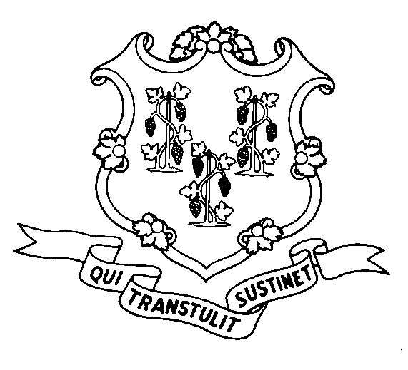
STATE OF CONNECTICUT
DEPARTMENT OF SOCIAL SERVICES
UNIFORM POLICY MANUAL

______________________________________ September 1, 2006
Claudette J. Beaulieu, Deputy Commissioner Effective Date

POLICY TRANSMITTAL NO.: UP-06-23

SUBJECT: Procedures for Documenting Application Dates and Recording Applications in
EMS.

This transmits revised instructions for mail-in or hand delivered applications. The application date must be the date the application is received by the department and this date must be clearly documented. The application must be date stamped the day it is received and screened in EMS by the end of the next business day.

These instructions were developed in response to recommendations from the department’s Office of Quality Assurance.

INSTRUCTIONS FOR UPDATING THE UPM:

Remove and Recycle Insert

P-1505.10 page 3 P-1505.10 page 3
********* P-1505.10 page 4
P-1505.15 P-1505.15

DISPOSITION: This Policy Transmittal may be recycled once the UPM has been updated.

DISTRIBUTION: UPM list

RESPONSIBLE UNIT: Adult Support, (860) 424-5250
Date Issued:

SM
25 SIGOURNEY STREET - HARTFORD, CONNECTICUT 06106-5033
An Equal Opportunity / Affirmative Action Employer
Printed on Recycled or Recovered Paper

