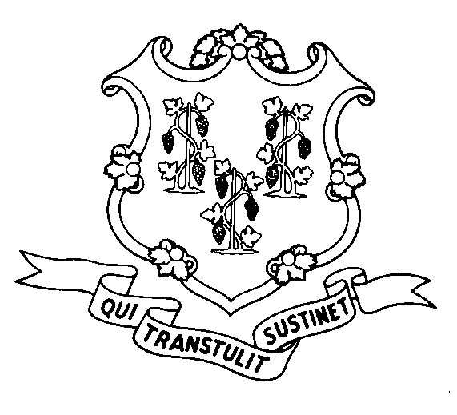
STATE OF CONNECTICUT
DEPARTMENT OF SOCIAL SERVICES
UNIFORM POLICY MANUAL

______________________________________ September 1, 2006
Claudette J. Beaulieu, Deputy Commissioner Effective Date

POLICY TRANSMITTAL NO.: UP-06-24

SUBJECT: Clarification of Student Status for the Food Stamp Program

This transmits clarification of the qualifications for students of higher education for participation in the Food Stamp Program. Included are corrections and additional factors that qualify students of higher education for Food Stamps. These policy revisions were made for consistency with federal regulations.

INSTRUCTIONS FOR UPDATING THE UPM:

Remove and Recycle Insert

3020/3020.05 3020/3020.05
3020.05 page 2/3020.05 page 3 3020.05 page 2/3020.05 page 3
P-3020.05 P-3020.05

DISPOSITION: This Policy Transmittal may be recycled once the UPM has been updated.

DISTRIBUTION: UPM list

RESPONSIBLE UNIT: Food Stamps, (860) 424-5383
Date Issued: 08/30/06

TG
25 SIGOURNEY STREET - HARTFORD, CONNECTICUT 06106-5033
An Equal Opportunity / Affirmative Action Employer
Printed on Recycled or Recovered Paper

