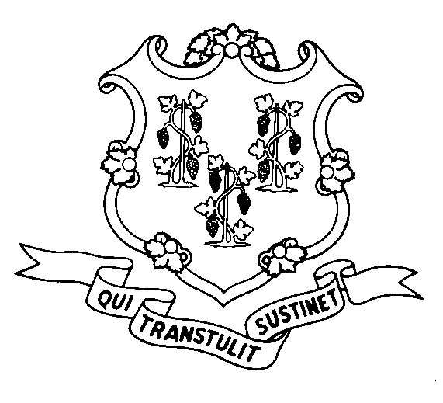
January 1, 2007

STATE OF CONNECTICUT

DEPARTMENT OF SOCIAL SERVICES

UNIFORM POLICY MANUAL

Claudette J. Beaulieu, Deputy Commissioner Effective Date

POLICY TRANSMITTAL NO.: UP-06-32

SUBJECT: Voter Registration Procedures

This transmittal issues technical changes to the procedures regarding voter registration. The changes indicate that the form W-614 may be used as well as the form ED-671 as an application for registration to vote. Additionally, it directs the individual who is responsible for forwarding applications for registration to the registrars of voters to issue a W-619 receipt for the voter registration application to the applicant or recipient.

In the near future, the department will be making changes to the application forms so that the declination form will be part of the application. This change will be phased in as supplies of application forms need to be replenished.

INSTRUCTIONS FOR UPDATING THE UPM:

Remove and Recycle Insert

P-1015.25 P-1015.25
P-1015.25 page 2 P-1015.25 page 2
****** P-1015.25 page 3

DISPOSITION:

This policy transmittal may be recycled once the UPM has been updated.

DISTRIBUTION: UPM List

RESPONSIBLE UNIT:

Adult Support, Telephone # (860) 424-5250 Date Issued:

RC#:

