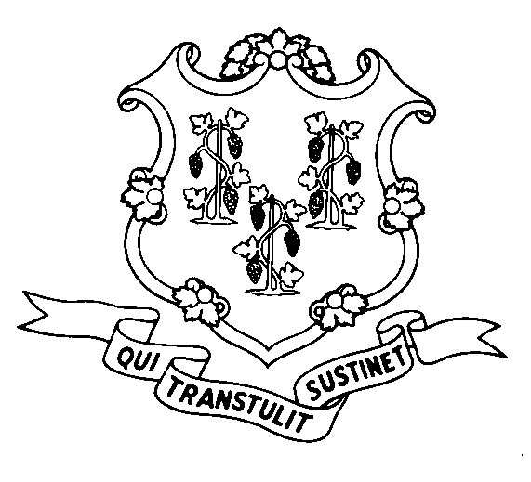
STATE OF CONNECTICUT
DEPARTMENT OF SOCIAL SERVICES
UNIFORM POLICY MANUAL

______________________________________ April 17, 2007
Claudette J. Beaulieu, Deputy Commissioner Effective Date

POLICY TRANSMITTAL NO.: UP-07-03

SUBJECT: Paying for Funeral and Burial Expenses

This transmittal provides revised UPM Procedures pages to reflect additional information to be requested by the department from a funeral home / vendor prior to the department authorizing payment for such funeral services to the funeral home / vendor.

INSTRUCTIONS FOR UPDATING THE UPM:

Remove and Recycle Insert

P-8080.90 Page 3 P-8080.90 Page 3
P-9005.05 P-9005.05

DISPOSITION: This Policy Transmittal may be recycled once the UPM has been updated.

DISTRIBUTION: UPM list

RESPONSIBLE UNIT: Fraud & Recoveries, (860) 424-5954
Date Issued:

25 SIGOURNEY STREET - HARTFORD, CONNECTICUT 06106-5033
An Equal Opportunity / Affirmative Action Employer
Printed on Recycled or Recovered Paper

