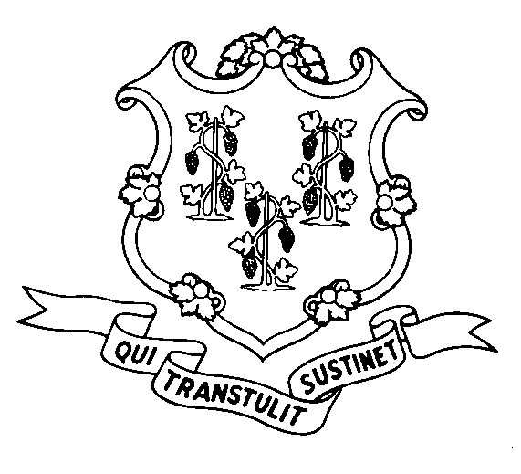
STATE OF CONNECTICUT
DEPARTMENT OF SOCIAL SERVICES
UNIFORM POLICY MANUAL

______________________________________ July 1, 2007
Claudette J. Beaulieu, Deputy Commissioner Effective Date

POLICY TRANSMITTAL NO.: UP-07-10

SUBJECT: Medically Needy Income Limit (MNIL) Increase

This transmittal provides revised UPM Procedures pages to reflect recent legislation passed by the General Assembly. The budget included a 3.2% cost of living increase for the TFA program. The MNIL is set by statute at 143% of the TFA payment standard and has thus been increased as well.

INSTRUCTIONS FOR UPDATING THE UPM:

Remove and Recycle Insert

P-4530.15 P-4530.15
P-4530.15 page 2 P-4530.15 page 2
P-4530.15 page 3 P-4530.15 page 3

DISPOSITION: This Policy Transmittal may be recycled once the UPM has been updated.

DISTRIBUTION: UPM list

RESPONSIBLE UNIT: Adult Support, (860) 424-5250
Date Issued:

SM

25 SIGOURNEY STREET - HARTFORD, CONNECTICUT 06106-5033
An Equal Opportunity / Affirmative Action Employer
Printed on Recycled or Recovered Paper

