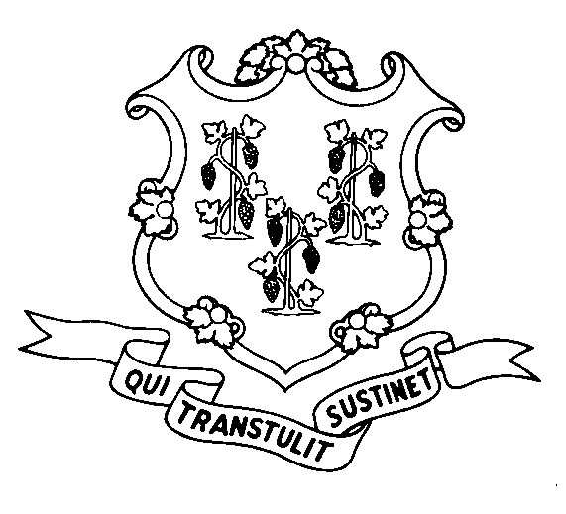
STATE OF CONNECTICUT
DEPARTMENT OF SOCIAL SERVICES
UNIFORM POLICY MANUAL

______________________________________ January 15, 2008
Claudette J. Beaulieu, Deputy Commissioner Effective Date

POLICY TRANSMITTAL NO.: UP- 08-01

SUBJECT: Definition of Real Property

The Uniform Policy Manual definition of Real Property has been amended to include any camper, trailer and mobile home that has been permanently affixed to the land.

INSTRUCTIONS FOR UPDATING THE UPM:

Remove and Recycle Insert

4000.01pg.6 4000.01pg.6
DISPOSITION: This Policy Transmittal may be recycled once the UPM has been updated.

DISTRIBUTION: UPM list

RESPONSIBLE UNIT: Fraud & Recovery, (860) 424-5967

Date Issued: 01-15-08
RC#: 2007--069

25 SIGOURNEY STREET - HARTFORD, CONNECTICUT 06106-5033
An Equal Opportunity / Affirmative Action Employer
Printed on Recycled or Recovered Paper

