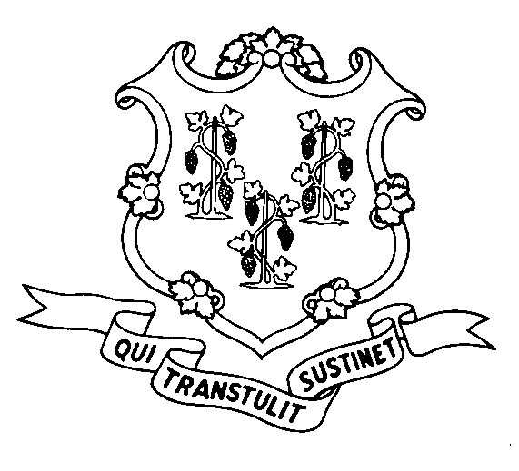
STATE OF CONNECTICUT
DEPARTMENT OF SOCIAL SERVICES
UNIFORM POLICY MANUAL

______________________________________ July 1, 2007
Claudette J. Beaulieu, Deputy Commissioner Effective Date

POLICY TRANSMITTAL NO.: UP-08-11

SUBJECT: Exclusion of Motor Vehicles as Assets for the Food Stamp Program

We are issuing policy to implement the provision of Public Act 07-63 that requires the Department to use the alternative motor vehicle evaluation provisions found in the federal regulations for the Food Stamp Program. This alternative provision allows the Department to treat motor vehicles the same for the Food Stamp Program as they are treated for the Care4Kids program. Under the Care4Kids program, all motor vehicles are excluded as assets. Therefore all motor vehicles are excluded as assets in the Food Stamp Program. Public Act 07-63 was effective July 1, 2007.

INSTRUCTIONS FOR UPDATING THE UPM:

Remove and Recycle Insert
4015.10/4015.15 4015.10/4015.15
4020.15 p7/p8 4020.15 p7/p8
4020.15 p9/p10 4020.15 p9/p10
4020.15 p11/p12 4020.15 p11
4030.55 p2/p3 4030.55 p2
4030.55 p4 **********************
P-4030.35 P-4030.35
P-4030.35 p2 P-4030.35 p2
P-4099.20 P-4099.20
P-4099.20 p2 **********************
P-4099.30 p2 P-4099.30 p2
P-4099.30 p3 P-4099.30 p3

DISPOSITION: This Policy Transmittal may be recycled once the UPM has been updated.

DISTRIBUTION: UPM list

RESPONSIBLE TEAM: Food Stamp Unit - phone # (860) 424-5383.

MP Date Issued:
RC# 07-13
25 SIGOURNEY STREET - HARTFORD, CONNECTICUT 06106-5033
An Equal Opportunity / Affirmative Action Employer
Printed on Recycled or Recovered Paper

