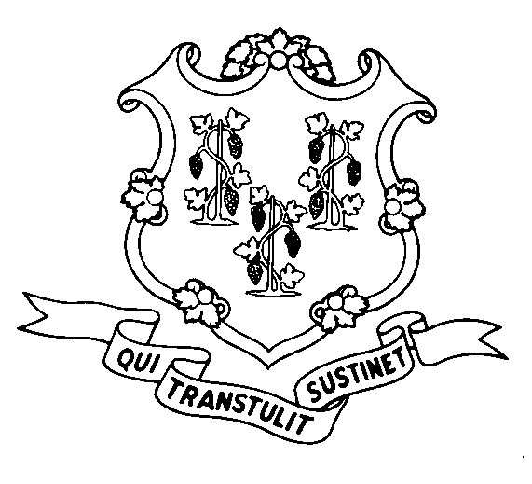
STATE OF CONNECTICUT
DEPARTMENT OF SOCIAL SERVICES
UNIFORM POLICY MANUAL

______________________________________ October 1, 2003
Claudette J. Beaulieu, Deputy Commissioner Effective Date

POLICY TRANSMITTAL NO.: UP-08-15

SUBJECT: Eligibility of Children Under 18 for Federal Food Stamps

This transmittal provides corrected UPM policy to reflect the federal regulations regarding the eligibility for the Food Stamp Program of children who are lawfully admitted non-citizens and who are under the age of 18. Previous policy stated such children were eligible if they had entered the U.S. prior to August 22, 1996. Corrected policy states that lawfully admitted non-citizen children under 18 are eligible regardless of the date of entry. The Legislative Regulation Review Committee approved this regulation change on June 24, 2008.

EMS processes eligibility for these children correctly.

INSTRUCTIONS FOR UPDATING THE UPM:

Remove and Recycle Insert

3005.06/3005.06 page 2 3005.06/3005.06 page 2
DISPOSITION: This Policy Transmittal may be recycled once the UPM has been updated.

DISTRIBUTION: UPM list

RESPONSIBLE UNIT: Food Stamp Unit, (860) 424-5383
Date Issued:

MP

25 SIGOURNEY STREET - HARTFORD, CONNECTICUT 06106-5033
An Equal Opportunity / Affirmative Action Employer
Printed on Recycled or Recovered Paper

