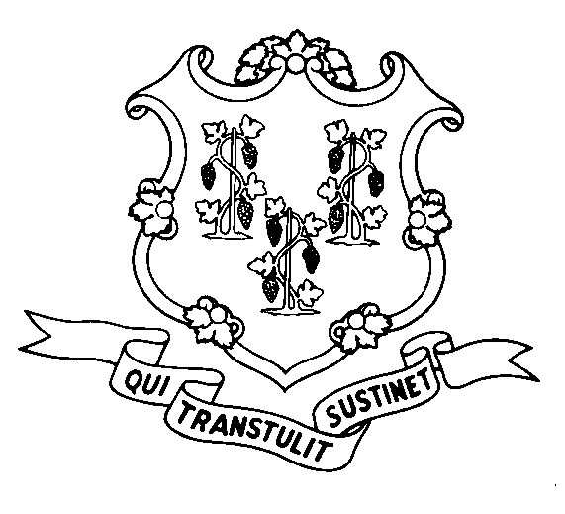
STATE OF CONNECTICUT
DEPARTMENT OF SOCIAL SERVICES
UNIFORM POLICY MANUAL

______________________________________ July 1, 2008
Claudette J. Beaulieu, Deputy Commissioner Effective Date

POLICY TRANSMITTAL NO.: UP-08-16

SUBJECT: Medically Needy Income Limit (MNIL) Increase

This transmittal provides revised UPM Procedures pages to reflect an increase in the MNIL. The increase is required by state statute every July 1. The MNIL is set at 143% of the TFA payment standard which also increased July 1. The new MNIL amounts will apply to both Medicaid and SAGA medical assistance cases.

INSTRUCTIONS FOR UPDATING THE UPM:

Remove and Recycle Insert

P-4530.15 P-4530.15
P-4530.15 page 2 P-4530.15 page 2
P-4530.15 page 3 P-4530.15 page 3

DISPOSITION: This Policy Transmittal may be recycled once the UPM has been updated.

DISTRIBUTION: UPM list

RESPONSIBLE UNIT: Adult Support, (860) 424-5250
Date Issued:

SM

25 SIGOURNEY STREET - HARTFORD, CONNECTICUT 06106-5033
An Equal Opportunity / Affirmative Action Employer
Printed on Recycled or Recovered Paper

