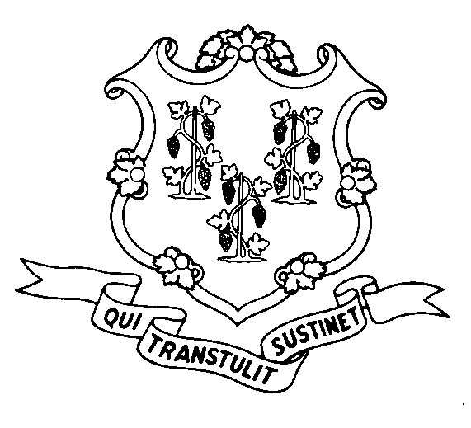
STATE OF CONNECTICUT
DEPARTMENT OF SOCIAL SERVICES
UNIFORM POLICY MANUAL

______________________________________ July 31, 2008
Claudette J. Beaulieu, Deputy Commissioner Effective Date

POLICY TRANSMITTAL NO.: UP-08-20

SUBJECT: Employed Disabled/Medicaid Waiver Link

This transmits revised policy under which an individual who is eligible for Medicaid under the S04 or S05 coverage groups is considered to meet the income and asset eligibility criteria of the Acquired Brain Injury (ABI) waiver, the Department of Developmental Services (DDS) Comprehensive waiver or the Department of Developmental Services Individual and Family Support waiver, as well as the Personal Care Assistance (PCA) waiver. The department is implementing this policy revision in accordance with Public Act 05-44. The revision became an official regulation on July 31, 2008, when it was filed at the office of the Secretary of the State.

Presently, an individual eligible for Medicaid under the Working Individuals with Disabilities coverage group (Medicaid for the Employed Disabled - S05) is considered to meet the income and asset eligibility criteria of the PCA waiver. However, an individual is not eligible for any of the other waivers described above unless he or she meets the income and asset limits of the Medicaid Home and Community-Based Services coverage group (W01). The income limit for this group is 300% of the maximum Supplemental Security Income amount for one person. The asset limit is $1,600.00.

Under this revision, an individual who is eligible for Medicaid under the S05 coverage group, and who also meets the medical and other non-financial requirements (including the transfer of asset requirement) of any of the above waivers is not subject to the income and asset limits normally applicable to an individual under the W01 coverage group.

In addition, an individual who is eligible for Medicaid under an S04 coverage group (either the Severely Impaired group or the Severely Impaired Non-SSI group), and who also meets the medical and other non-financial requirements (including the transfer of asset requirement) of any of the above waivers is not subject to the income and asset limits normally applicable to an individual under the W01 coverage group.

Presently, in processing W01 cases, DSS regional office Adult Services staff determines whether an individual meets the medical criteria to receive services under the PCA and ABI waivers. DDS staff determines whether an individual meets the medical criteria to receive services under the two DDS waivers. After approving an individual’s eligibility to receive waiver services, the DSS Adult Services staff or DDS staff sends form W-1518 (Home and Community Based Services Waiver Referral to Regional Office) to the DSS regional office eligibility worker. The DSS eligibility worker then makes the final eligibility determination based on the financial and non-financial criteria governing the W01 coverage group.

The process described above is not changing. However, under this policy revision, the DSS eligibility worker will not need to consider an individual’s income and assets in determining the individual’s eligibility for the above waiver services if the individual qualifies for Medicaid under the S04 or S05 coverage group.

INSTRUCTIONS FOR UPDATING THE UPM:

Remove and Recycle Insert

2540.92/2540.94 2540.92/2540.92 page 2
2540.94 page 2/2540.95 2540.94/2540.94 page 2
2540.95 page 2/2540.96 2540.95/2540.95 page 2
****** 2540.96

DISPOSITION: This Policy Transmittal may be recycled once the UPM has been updated.

DISTRIBUTION: UPM list

RESPONSIBLE UNIT: Adult Support, (860) 424-5250
Date Issued: 8-15-08

RA

25 SIGOURNEY STREET - HARTFORD, CONNECTICUT 06106-5033
An Equal Opportunity / Affirmative Action Employer
Printed on Recycled or Recovered Paper

