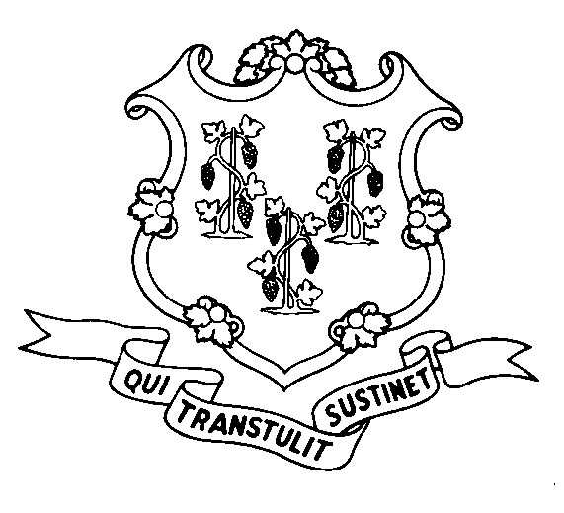
STATE OF CONNECTICUT
DEPARTMENT OF SOCIAL SERVICES
UNIFORM POLICY MANUAL

______________________________________ September 1, 2008
Claudette J. Beaulieu, Deputy Commissioner Effective Date

POLICY TRANSMITTAL NO.: UP - 08-22

SUBJECT: Clarification of Policy Regarding Waiver of Face-to-Face Interview at Redetermination for SNAP Eligibility

We have modified Section 1545.20 of the UPM to clarify that the rules regarding waiving the face-to-face interview for SNAP are the same at redetermination as they are at application. The face-to-face interview can be waived if the recipient has good cause for not coming into the office. Good cause includes, but is not limited to, illness, severe weather, death in the immediate family, a conflict between the Department’s business hours and the client’s work or training schedule, transportation difficulties or other circumstances beyond the client’s control.

Although the USDA has changed the name of the Food Stamp Program to the Supplemental Nutrition Assistance Program, or SNAP, effective October 1, 2008, some policy will continue to be issued with the terms “Food Stamps” or “FS” because the pertinent regulation was promulgated long before the name change. To change “Food Stamps” to “SNAP” in the UPM requires a regulation change, which must occur through the state regulatory process set forth in the Uniform Administrative Procedures Act. Therefore you will continue to see “Food Stamps” in newly issued UPM until all regulations currently in the process have been promulgated.

INSTRUCTIONS FOR UPDATING THE UPM:

Remove and Recycle Insert
1545.20/1545.20 page2 1545.20/1545.20 page 2

DISPOSITION: This Policy Transmittal may be recycled once the UPM has been updated.

DISTRIBUTION: UPM list

RESPONSIBLE UNIT: SNAP Unit, (860) 424-5383
Date Issued:

25 SIGOURNEY STREET - HARTFORD, CONNECTICUT 06106-5033
An Equal Opportunity / Affirmative Action Employer
Printed on Recycled or Recovered Paper

