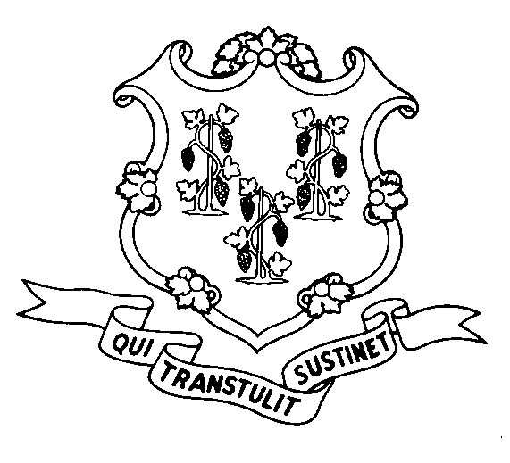
STATE OF CONNECTICUT
DEPARTMENT OF SOCIAL SERVICES
UNIFORM POLICY MANUAL

____________________________________ October 1, 2008
Claudette J. Beaulieu, Deputy Commissioner Effective Date

POLICY TRANSMITTAL NO.: UP-08-24

SUBJECT: Technical Revisions to Policy about Categorically Eligible SNAP Assistance Units

This transmits technical revisions to UPM section 2545 previously transmitted by UP-08-07 that have been mandated by the Legislative Regulations Review Committee (LRRC).

INSTRUCTIONS FOR UPDATING THE UPM:

Remove and Recycle Insert

2545/2545.05 2545/2545.05

DISPOSITION: This Policy Transmittal may be recycled once the UPM has been updated.

DISTRIBUTION: UPM list

RESPONSIBLE UNITS: Food Stamp Unit, (860) 424-5383

MP Date Issued:
RC# 08-03

