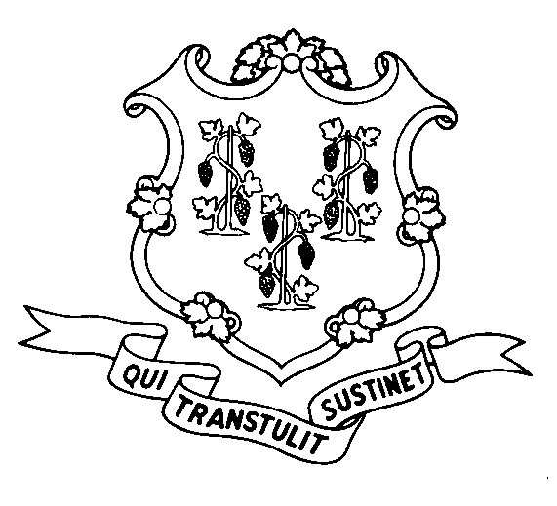
STATE OF CONNECTICUT
DEPARTMENT OF SOCIAL SERVICES
UNIFORM POLICY MANUAL

______________________________________ July 20, 2008
Claudette J. Beaulieu, Deputy Commissioner Effective Date

POLICY TRANSMITTAL NO.: UP- 08-26

SUBJECT: Removal of Liens in the Medicaid program

The Uniform Policy Manual has been amended to eliminate the requirement for removal of liens against real property in the Medicaid program when an institutionalized recipient dies.

Please note that under certain conditions, regardless of whether we have a lien on the property, we do not recover Medicaid benefits from such property. We do not recover if the deceased recipient’s sibling is still living in the property and is a joint owner. We also do not recover if the deceased recipient’s adult child is still living in the property, and such child prevented the recipient from needing institutionalization for at least two years. We will be revising UPM 7525.10 B. shortly to describe these restrictions to recovery.

INSTRUCTIONS FOR UPDATING THE UPM:

Remove and Recycle Insert

7510.15 pgs. 2 - 3 7510.15 pg 2
DISPOSITION: This Policy Transmittal may be recycled once the UPM has been updated.

DISTRIBUTION: UPM list

RESPONSIBLE UNIT: Fraud & Recovery, (860) 424-5967
Date Issued: 1-12-09
RC#: 2008-016

25 SIGOURNEY STREET - HARTFORD, CONNECTICUT 06106-5033
An Equal Opportunity / Affirmative Action Employer
Printed on Recycled or Recovered Paper

