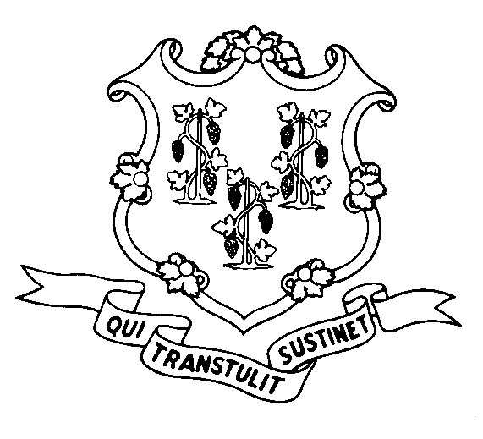
STATE OF CONNECTICUT
DEPARTMENT OF SOCIAL SERVICES
UNIFORM POLICY MANUAL

______________________________________ January 7, 2009
Claudette J. Beaulieu, Deputy Commissioner Effective Date

POLICY TRANSMITTAL NO.: UP-09-02

SUBJECT: Long Term Care Diversion of Income Increase

This transmits policy to increase in the amount of income diverted for the cost of maintaining a home in the community from $450.00 to $650.00 for Level 1 Housing, as defined in section 4520.15 C.1 of the UPM; and (2) to increase in the amount of income diverted for the cost of maintaining a home in the community from $250.00 to $400.00 for Level 2 Housing, as defined in section 4520.15 C.2 of the UPM.

This regulation is effective January 7, 2009, the date it was filed with the Secretary of the State’s office.

INSTRUCTIONS FOR UPDATING THE UPM:

Remove and Recycle Insert
5035.20/5035.20 page 2 5035.20/5035.20 page 2

DISPOSITION: This transmittal may be retained for reference.

DISTRIBUTION: UPM List

RESPONSIBLE UNIT: Adult Support - (860) 424-5250

MDB Date Issued: 1-21-2009

Reg. Control No. 07-27

25 SIGOURNEY STREET - HARTFORD, CONNECTICUT 06106-5033
An Equal Opportunity / Affirmative Action Employer
Printed on Recycled or Recovered Paper

