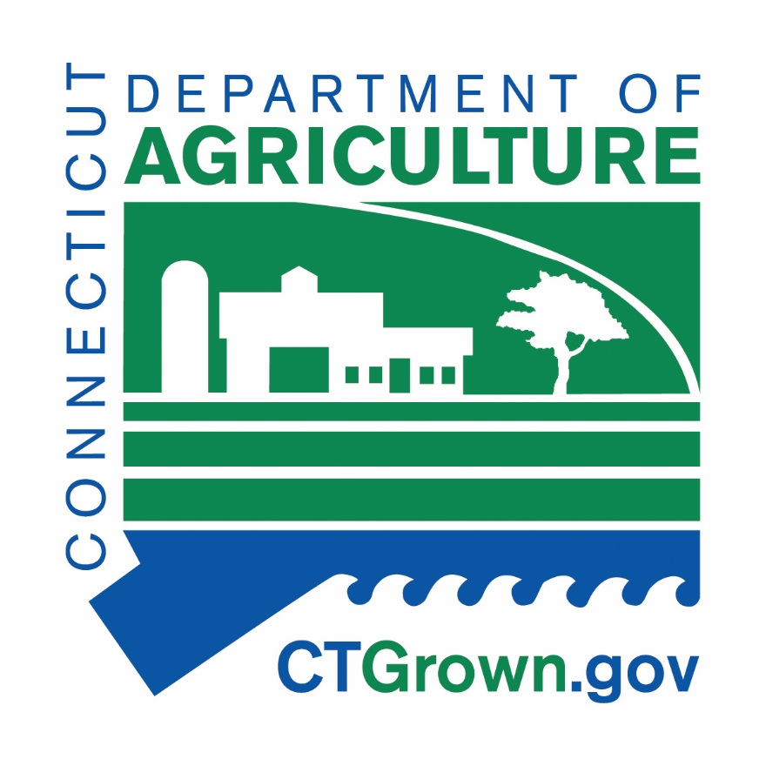

S T A T E O F C O N N E C T I C U T
DEPARTMENT OF AGRICULTURE
Agricultural Development Unit

CT HONEY PRODUCERS WEBSITE LISTING

**You must be a registered beekeeper with the CT Ag Experiment Station (CAES) and produce honey and honey products.**
**Your application will be sent to CAES before posting to our site. **

FARM NAME____________________________________________

YOUR NAME_____________________________________________

FARM ADDRESS__________________________________________________

TOWN________________________ STATE__________ ZIP___________________

MAILING ADDRESS (if different)______________________________________________

Business PHONE NUMBER ______________________ YOUR CELL (not published) _____________________

FAX NUMBER (with area code)_________________________ Business E-MAIL_________________________________

COUNTY ____________________________________ WEBSITE________________________________________

SOCIAL MEDIA (give us addresses, we will link) ___________________________________

_________________________ __________________________ _____________________________

BRIEF DESCRIPTION, 30 WORDS MAX. Longer entries will be shortened.

_________________________________________________________________________________

_________________________________________________________________________________

_______________________________________________________________________________________________________

________________________________________________________________________________________________________

COMPLETE IN FULL and return Fax: 860-730-8322 E-Mail: Jane.Murdock@ct.gov
US Mail:
CT DEPT OF AGRICULTURE – Agricultural Development Unit
450 Columbus Boulevard, Suite 703
HARTFORD, CT 06103
Rev. 2018

Equal Opportunity Employer

