Juvenile Justice Advisory Committee
Annual Report to the Governor and General Assembly
July 1, 2015 through June 30, 2016
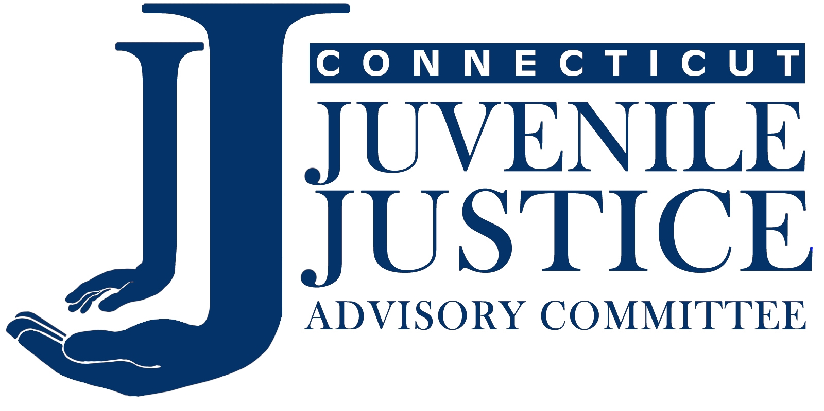
The Juvenile Justice Advisory Committee (JJAC) is the Governor-appointed committee responsible for overseeing the distribution and use of federal funds under the Juvenile Justice and Delinquency Prevention (JJDP) Act in Connecticut. The purpose of the Juvenile Justice Advisory Committee is to prevent delinquency and improve Connecticut’s juvenile justice system.
MAJOR ACCOMPLISHMENTS OF 2015/2016

- Trained All Staff in 13 Schools to Improve School Discipline

- Effective School Staff Interactions with Students and Police: A Training Model

Best practices for creating partnerships between schools and police are presented.
Trainers and trainees share practical strategies for handling student misbehavior.
Data by race/ethnicity on school disciplinary incidents shows significant disproportion.
Data on out-of-school suspensions varies enormously by school district.

- Research Design to Measure Training Outcomes

- Related Efforts to Address Unequal Treatment in the Juvenile Justice System
Police Training and Programming
Studying the Connecticut Data

2) Improved School Attendance

- School Attendance Model Kindergarten Program

- Connecticut Consortium on School Attendance

3) Updated and Revised the JJAC Web Site
MAJOR ACCOMPLISHMENTS OF 2015/2016

1) Trained All Staff in 13 Schools to Improve School Discipline

With support from a National Institute of Justice research grant, the Juvenile Justice Advisory Committee (JJAC) trained 1,349 persons in the JJAC-developed curriculum called Effective School Staff Interactions with Students and Police (ESSI). The 13 schools are:

Ansonia High School
Bassick High School (Bridgeport)
East Hartford Middle School
Hamden Middle School
Harding High School (Bridgeport)
New Britain High School
Platt Technical High School (Milford)
Ponus Ridge Middle School (Norwalk)
Pulaski Middle School (New Britain)
Slade Middle School (New Britain)
West Haven High School
West Rocks Middle School (Norwalk)
West Side Middle School (Waterbury)

Effective School Staff Interactions with Students and Police: A Training Model

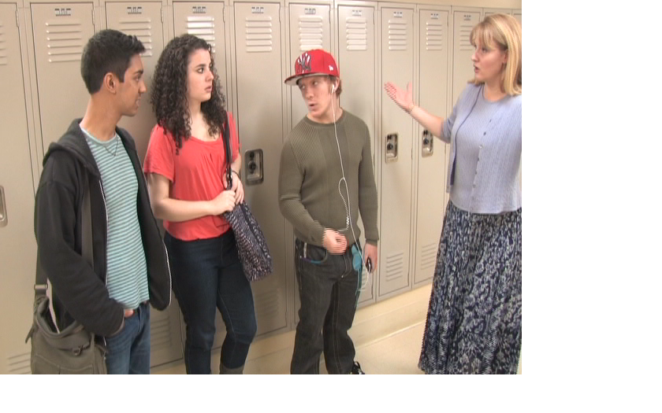
Schools and law enforcement share responsibility for school safety and must work together with complimentary policies and procedures to ensure a safe learning environment for students. Creating a collaborative strategy to guide school/police efforts in the state was a goal of the JJAC and its School/Police Task Group. Its products included a model Memorandum of Agreement (MOA) between the superintendent of schools and the chief of police meant to be a starting point for local communities to collaborate and ensure a consistent application of sanctions for school misbehavior, and Effective School Staff Interactions with Students and Police (ESSI). Information on both is available at RightResponseCT.org.

Tailored for all staff working in schools, the one-day training covers youth behavior, strategies for interacting effectively with students, the role of law enforcement in schools, and how the juvenile justice system works. Trainees are introduced to some disturbing data about how discipline is meted out in Connecticut schools, including rates of disciplinary incidents broken out by race for every school district. Statewide in 2014/2015, black students were 5½ times more likely than white students to have their behavior identified by school officials as a disciplinary incident; for Hispanic students it was 3½ times more likely. “We’re not saying that any district or individual is mistreating minority students,” says Sergeant Andre Parker of the Mashantucket Pequot Tribal Police, one of the co-facilitators. But regardless of intention, disproportionate outcomes are clear. The training also presents data gathered by the Department of Public Health that show adolescent behavior is quite similar across race and ethnicity. In other words: The problem does not lie in student behavior, but in how adults respond to it.

The training also presents national research and local Connecticut data on exclusionary disciplinary practices, including findings that: 1) high suspension rates do not improve learning conditions or make schools safer; and 2) differences in the use of out-of-school suspension are due to factors within the control of schools and schools can reduce rates.
Research Design to Measure Training Outcomes

The JJAC applied to, and was selected for funding by, the National Institute of Justice (NIJ) to enhance the evaluation of the school curriculum by training all staff in 13 schools and answering the following research question: “Can the one-day training change the behavior of school staff such that out-of-school sanctions, referrals to juvenile court and disproportionate treatment of students based on race/ethnicity are reduced, and school climate is improved?” Data pre and post training will be collected directly from the State Department of Education and the Judicial Branch for the 13 participating schools and 13 matched schools.

Related Efforts to Address Unequal Treatment in the Juvenile Justice System

Police Training and Programming
Although police officers are trained in “human relations,” there is little training on the differences in policing adults versus adolescents. Effective Police Interactions with Youth, a one-day training for patrol officers developed by the JJAC, is delivered by two police trainers in a classroom setting and is focused on the interplay between line officers and juveniles when they meet in non-dangerous situations. It provides patrol officers with the knowledge needed to differentiate problematic adolescent behavior from typical adolescent behavior, and the skills to de-escalate situations involving agitated/defiant youth and prevent situations from escalating in the first place. It also addresses the difficult problem of DMC. The JJAC presented this training 4 times with no registration fee and trained 95 Connecticut officers.

Effective Police Interactions with Youth is also shared with other states. For 2015/2016 presentations were held in Oklahoma City, Oklahoma; Louisville, Kentucky; Las Vegas, Nevada; Norfolk, Virginia; South Carolina; Massachusetts; Denver, Colorado; DuPage, DeKalb and Kane counties Illinois; Fulton County, Georgia; and Fargo, North Dakota.

The JJAC continued its funding for police/youth-type projects. The goals of these projects are to increase the number of police officers who are experienced and comfortable interacting with youth and to improve youth attitudes towards police. Required components are:
  - Involve patrol officers without regular interaction with youth, and who attend the one-day training Effective Police Interactions with Youth.
  - Plan for and with a small mixed group (15-25) of youth in grades 6-12.
  - Offer a series of appealing activities to the youth and officers at group sessions.
  - Ensure leadership roles for youth and non-authoritarian roles for police (no teaching).
  - Collaborate on a service project to enhance interaction and develop community support.
For 2015/2016 nine communities operated Police and Youth Programs. The JJAC selected an additional 10 communities to fund for 2016/2017.

Studying the Connecticut Data
Because of significant changes to the juvenile justice system (changing jurisdictional age and limiting police discretion for secure detention), it is important for DMC planning to conduct another statewide assessment study to obtain updated information. A contract was put in place with Spectrum Associates Market Research on June 5, 2015. It is expected that this fourth assessment study with JJAC recommendations will be published in fall 2017.
A second research project is a follow up survey of state agency system practitioners (except law enforcement) to document changes in awareness levels of DMC and contrast findings over time. The survey findings included:
1. JJAC efforts appear to have been successful in increasing practitioner awareness of DMC.
2. Respondents expressed the greatest familiarity with the following JJAC initiatives:
- Requiring a court order for the police to bring any juvenile to a pretrial detention center.
- The Color of Justice documentary.
- The Color of Justice forums.
3. Respondents who were familiar with the JJAC initiatives typically rated these initiatives as “somewhat” or “very” effective. Practitioners rated as most effective:
- Memorandum of Agreement between the school superintendent and the chief of police.
- Police training curriculum to assist police in working more effectively with youth.
- Requiring a court order for police to bring juveniles to a pretrial center detention.
- Curriculum to assist school staff in working more effectively with students and police.
4. Practitioners appear to making little use of the JJAC websites—CTJustStart.org and RightResponseCT.org.

2) Improved School Attendance

School Attendance Model Kindergarten Program
For the past two school years the JJAC awarded funding to 10 school districts to implement a model kindergarten program in 54 schools. Monies also went to the University of Connecticut to evaluate the programs. The kindergarten model involves an outreach worker for five hours per week in each school to monitor kindergarten student attendance data, consult and collaborate with the school’s attendance team, and contact the families of kindergarten students identified early on as being, or at risk of becoming, chronically absent. Evaluation results are expected by January 2017. A competitive process identified 11 school districts for funding during the 2016/2017 school year.

Connecticut Consortium on School Attendance
The Connecticut Consortium on School Attendance is an association of local school and statewide agency representatives focused on raising school attendance by improving the collection and use of student attendance data. Districts may join the Consortium at any time with a letter from the superintendent and submission of district attendance data. The school district members are eligible to apply for JJAC School Attendance Program grants, are provided with an analysis of attendance data for the Consortium as a whole and by district, and can take part in Consortium meetings and an annual “retreat.” The 11th Annual Fall Retreat of the Connecticut Consortium on School Attendance was held on November 23 & 24, 2015. The focus was on trauma informed schools. The film Paper Tigers was shown at a movie theater and the guest speaker was Jim Sporleder, the school principal at the school showcased in the film. There was also a panel of Connecticut educators who discussed trauma informed practices.

3) Updated and Revised the JJAC Web Site

The web site for JJAC activities has been updated with increased connectivity among the various pages. To see 20 charts with primarily 2015 data, click here. Other updated pages include CTJustStart.org, which addresses disproportionate minority contact and RightResponseCT.org, which looks at school police collaboration.

