INTERGOVERNMENTAL POLICY DIVISION

TO: Members of the Municipal Finance Advisory Commission

FROM: W. David LeVasseur, Undersecretary 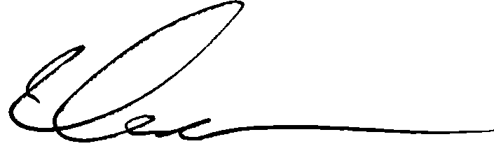
Intergovernmental Policy Division

DATE: May 11, 2009

SUBJECT: Regular Meeting – Thursday May 14, 2009

The next meeting of the Municipal Finance Advisory Commission is scheduled for Thursday, May 14, 2009 at the Office of Policy and Management, 450 Capitol Avenue, Hartford, CT 06106 in Room 4A from 10:00 -12:00.

The Agenda is as follows:

- Call to order.

- Approval of the minutes to the March 24, 2009 meeting.

- Update and discussion of finances of the West Haven.

- FY 2007-08 Audit Reports Submission Status / Electronic Submission of Reports

- Preparation of Municipal Fiscal Indicators

- Session Year 2009 Proposed Legislation.

- GFOA Fiscal Health Project

- Other Business.

As always, you can reach me at 860-418-6484 or Lori Stevenson at 860-418-6402. The office’s fax number is 860-418-6493.

Cc: Secretary of State
State Treasurer’s Office
Mayor John Picard, City of West Haven

