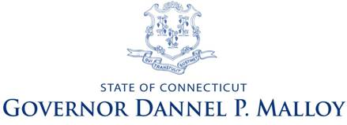
Governor’s Cabinet on Nonprofit Health and Human Services
December 10, 2012
2:00 – 4:00
Legislative Office Building Room 2B
Agenda
- Welcome/ Introductions
Peter S. DeBiasi - President/CEO, The Access Community Action Agency, Cabinet Co-Chair
Terry Edelstein, Nonprofit Liaison to the Governor, Cabinet Co-Chair

- Greeting from Governor Dannel P. Malloy
- Presentations from the Working Group Co-Chairs
Common Cross-Agency Population Results
Nancy Roberts, President and CEO, Connecticut Council for Philanthropy
William Carbone, Executive Director, Court Support Services Division of the Judicial Branch

Rate Setting Methodology
Patrick J. Johnson, Jr., President, Oak Hill
Scott McWilliams, DMHAS Budget Director

RFP and Procurement Processes
Anne L. Ruwet, CEO, CCARC, Inc
Chris Andresen, Section Chief, DPH (unable to attend)

- Conclusions from the Working Groups – Peter DeBiasi, Cabinet Co-Chair
- Governor Malloy’s Charge to the Cabinet
- Review of Working Group Tasks and Organizational Structure
- Proposed Meeting Schedule & Structure
Work Groups | January 2013 and ongoing
Cabinet Meeting | Friday, January 25, 2013 - 10:00 – 11:30
Cabinet Meeting | Friday, March 22, 2013 - 10:00 – 11:30
Cabinet Meeting | Friday, May 24, 2013 - 10:00 – 11:30
Cabinet Meeting | Friday, June 7, 2013 - 10:00 – 11:30
Cabinet Meeting | Friday, June 21, 2013 - 10:00 – 12:00

