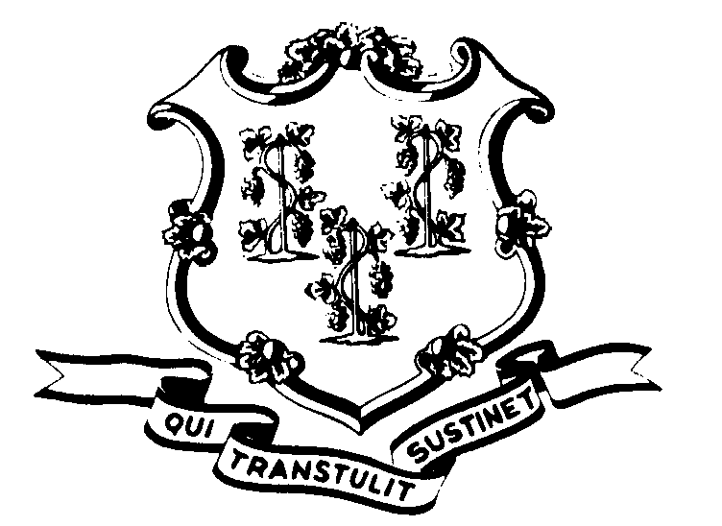STATE OF CONNECTICUT

OFFICE OF POLICY AND MANAGEMENT

Office of Labor Relations

February 8, 2000

General Notice No. 2000-02

TO: Labor Relations Designees

SUBJECT: FOI and Grievance and Arbitration Hearings

Marc S. Ryan, Secretary of OPM has directed me to follow new procedures that reflect his belief that we should honor the public’s right to know:
The procedures are as follows:
- All grievances and arbitrations that the Office of Labor Relations conducts or is involved with shall be posted in the Secretary of the State’s Office. The grievance sessions shall be open to the public and reporters shall have the right to attend such hearings and examine any documents not specifically exempt from disclosure.
- In arbitration sessions, the Office of Labor Relations shall affirmatively argue that the state believes such sessions should be open to the public. At that point, it is up to the arbitrator, based on AAA rules, to decide if the session will be open.
These procedures will remain in place unless the Attorney General’s Office informs this agency that they violate rights to personal privacy, collective bargaining or other pertinent statutes.
While Secretary Ryan’s new procedure only references reporters, the new procedure would apply to all members of the public.

Employees with questions should contact their Agency Personnel Office. Questions from Agency Personnel Officers may be addressed to me at 418-6446.

Linda J. Yelmini

Linda J. Yelmini
Director of Labor Relations

