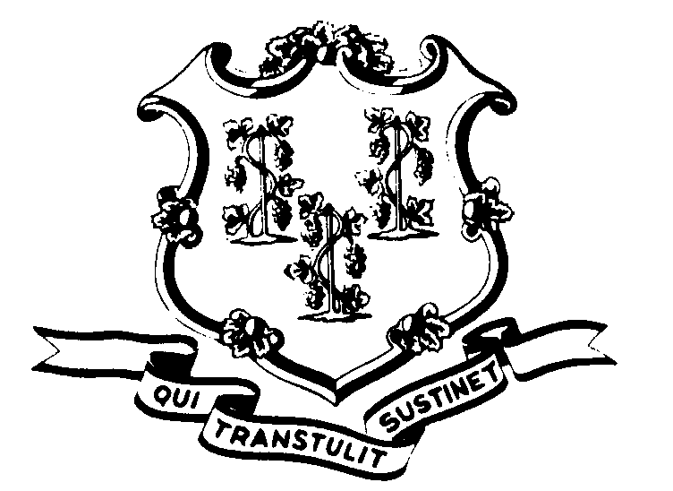STATE OF CONNECTICUT

OFFICE OF POLICY AND MANAGEMENT

Office of Labor Relations

June 22, 2000

General Notice No. 2000-11

TO: Labor Relations Designees

SUBJECT: Administrative and Residual Union - Arbitration Award

The legislature approved the interest arbitration award for the A&R union on Monday, June 19, 2000. On May 22, 2000, the State filed an Application to Vacate the Award. A briefing schedule has been established. The Office of the Attorney General expects that a decision in this matter will be issued in the early Fall.
During the pendency of the legal proceedings, the A&R award will not be implemented. We will keep you apprised of the developments in this matter.
Employees with questions should contact their Agency Personnel Office. Questions from Agency Personnel Officers may be addressed to Fae Brown-Brewton, who can be reached at 418-6217 or me at 418-6446.

Linda J. Yelmini

Linda J. Yelmini
Director of Labor Relations

