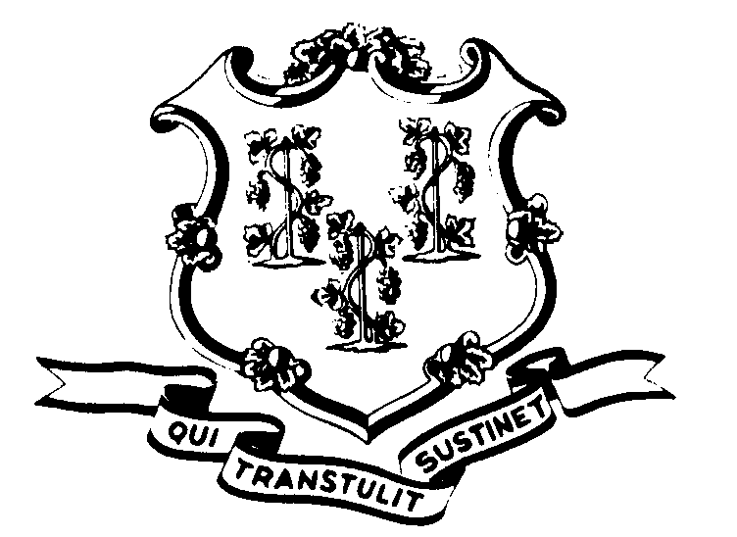STATE OF CONNECTICUT

OFFICE OF POLICY AND MANAGEMENT

Office of Labor Relations

July 6, 2000

General Notice No. 2000-12

TO: Agency Heads and Labor Relations Designees

SUBJECT: Administrative and Residual Union - Letter from Michael Winkler

Many of you have received a letter from Michael Winkler, President of the Administrative and Residual Union that contains erroneous information. Until you receive a notice from the Office of Labor Relations regarding the status of the appeal of the A&R Interest Arbitration Award, do not implement the award.
The dispute between the A&R Union and the State of Connecticut concerns the issue of flextime. The Office of the Attorney General has filed an Application to Vacate the Award. At the heart of the dispute is arbitrator error. While the legislature approved the Award, due to the arbitrator error, the Award is defective and cannot be implemented until the issue of Arbitrator error is resolved by the judicial system.
This is a legal dispute that will either be resolved within the judicial system or by agreement of the parties. Any future communiqués from Mr. Winkler or the A&R Union regarding the award, including grievances, should not be acted upon by agencies. Kindly send them on to OLR and we will handle them centrally.
Employees with questions should contact their Agency Personnel Office. Questions from Agency Personnel Officers may be addressed to Fae Brown-Brewton, who can be reached at 418-6217 or me at 418-6446.

Linda J. Yelmini

Linda J. Yelmini
Director of Labor Relations

