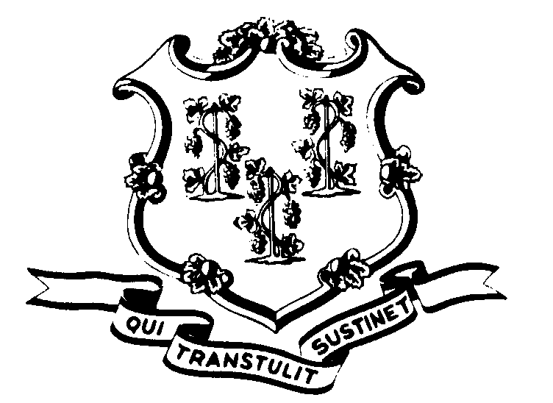STATE OF CONNECTICUT

OFFICE OF POLICY AND MANAGEMENT

Office of Labor Relations

August 22, 2000

OFFICE OF LABOR RELATIONS

GENERAL NOTICE 2000-15a

TO: Labor Relations Designees

FROM: Office of Labor Relations

SUBJECT: Additional Title for NP-2 Unit Classifications

Please add the title of Qualified Craft Worker (Automotive & Mechanical Equipment) to the list that was included in General Notice 2000-15.

Thank you.

Linda J. Yelmini
Linda J. Yelmini
Director of Labor Relations

