STATE OF CONNECTICUT
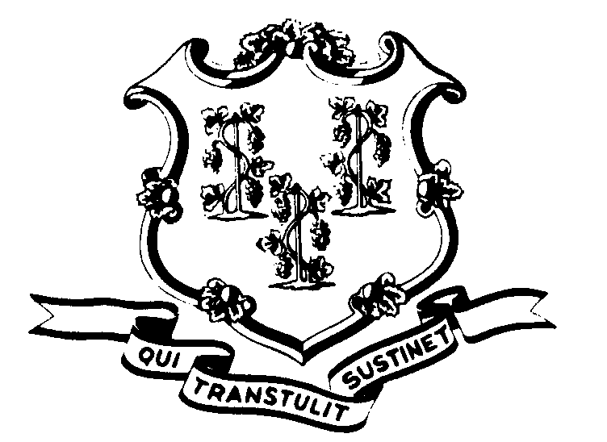

OFFICE OF POLICY AND MANAGEMENT

Office of Labor Relations

November 7, 2000

General Notice No. 2000-18B

TO: Agency Heads and Labor Relations Designees

SUBJECT: Arbitration Award -- P-5 Employee Leave Balances

This is to notify you that the dispute regarding the language and employee signature on the A&R Additional Leave Calculation Form will be resolved by Arbitrator Harvey Shrage and a ruling issued within a matter of weeks. The State and the Union have presented their arguments in conference calls with the Arbitrator and will be submitting written statements and exhibits regarding this matter. It is anticipated that Arbitrator Shrage will render his ruling by the end of this month, if not sooner.

We are continuing to advise that additional leave balances not be granted without a signed form from the employee accepting the increased amounts for the July 1, 1998 schedule change. In cases of employee hospitalization or serious incapacity, we recommend that the additional leave be calculated and granted and the employee be asked to sign the form as soon as he/she is able. The forms of the employees who have refused to sign and/or added comments to the form should be kept on hold pending the resolution of the arbitration remedy question. Similarly, if your agency has not yet distributed the calculation forms, you may wish to withhold distribution pending the arbitrator’s decision.

Employees with questions about this policy and procedure should contact their Agency Human Resources Offices. Questions from Agency Personnel Officers should be addressed to Ellen Carter of the Office of Labor Relations at 418-6218.

Linda J. Yelmini

Linda J. Yelmini
Director of Labor Relations

