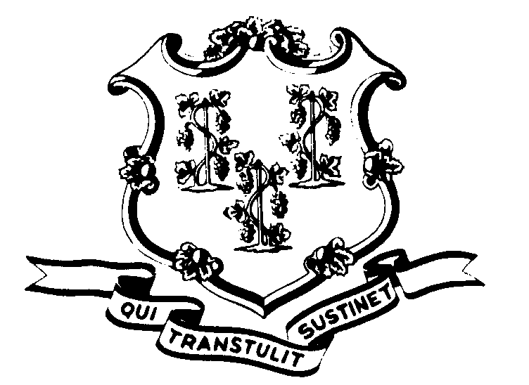STATE OF CONNECTICUT

OFFICE OF POLICY AND MANAGEMENT

Office of Labor Relations

March 8, 2001

General Notice 2001-03

TO: Labor Relations Designees

SUBJECT: March 5 and 6 Snow Storm

On Monday and Tuesday, March 5 and 6, 2001, Governor John G. Rowland asked nonessential state employees not to report to work because of the adverse weather conditions.

Consistent with past practice, contractual and statutory provisions, you are reminded of the following:

- Nonessential employees scheduled to work on either day will record their absence by the symbol “WW”. Essential employees who did report to work will be paid in accordance with contractual and statutory provisions. Essential employees are not eligible for compensatory time off.
- Employees who were not scheduled to work on March 5 and/or March 6 are not covered by the Governor’s request. Employees absent because of illness or scheduled to take vacation leave, personal leave or other earned time shall have the appropriate leave balance charged and shall not be eligible for “WW” time. Employees on leave of absence without pay (including voluntary leave) or other scheduled day off, such as a pass day or “flex” day, shall not be eligible for “WW” time.
Labor Relations Designees with questions should be directed to the Office of Labor Relations at 418-6447. All others should contact their Central Personnel Office.

Linda J. Yelmini
Linda J. Yelmini
Director of Labor Relations

